RUMOR DETECTION

TABLE OF CONTENT

PAGE  NO | TITLE | PAGE NO
 | ABSTRACT
 | LIST OF FIGURE
 | LIST OF ABBREVATIONS
1 | INTRODUCTION
2 | LITERATURE SURVEY
3 | SYSTEM ANALYSIS  - EXISTING SYSTEM  - DISADVANTAGES  - PROPOSED SYSTEM  - ADVANTAGES
4 | SYSTEM SPECIFICATIONS  - HARDWARE REQUIREMENTS  - SOFTWARE REQUIREMENTS
5 | SYSTEM IMPLEMENTATION  - MODULES  - MODULE DECRIPTION
6 | SYSTEM DESIGN

  - SYSTEM ARCHITECTURE
  - DATA FLOW DIAGRAM
  - UML DIAGRAM
    - USE CASE DIAGRAM
    - CLASS DIAGRAM
    - SEQUENCE DIAGRAM
    - ACTIVITY DIAGRAM
7 | SOFTWARE DESCRIPTION  - FRONT END  - BACK END
8 | SYSTEM TESTING  - TESTING PROCESS  - TYPES OF TESTING
9 | CONCLUSION & FUTURE ENHANCEMENT  - CONCLUSION  - FUTURE ENHANCEMENT
10 | APPENDICES  APPENDIX 1– SOURCECODE  APPENDIX 2 - SCREENSHOTS

ABSTRACT

In our modern era where the internet is ubiquitous, everyone relies on various online resources for news. Along with the increase in the use of social media platforms like Face book, Twitter, etc. news spread rapidly among millions of users within a very short span of time. The spread of Rumor has far-reaching consequences like the creation of biased opinions to swaying election outcomes for the benefit of certain candidates. Moreover, spammers use appealing news headlines to generate revenue using advertisements via click-baits. In this paper, we aim to perform j48 classification algorithm of various news articles available online with the help of concepts pertaining to Artificial Intelligence and Machine Learning. We aim to provide the user with the ability to classify the news as fake or real and also check the authenticity of the website publishing the news.

LIST OF FIGURES

TABLE OF CONTENT

FIGURE NO. | TITLE | PAGE NO
6.1 | SYSTEM ARCHITECTURE
6.2 | DATA FLOW DIAGRAM
6.3 | UML DIAGRAM
6.3.1 | USE CASE DIAGRAM
6.3.2 | CLASS DIAGRAM
6.3.3 | SEQUENCE DIAGRAM

CHAPTER – 1

INTRODUCTION

A great deal of Rumor is roaring through the various social media platforms. During this case classification of any news, post, story, journal into fake or real one has become a crucial them as fake and true and it's conjointly attracted a good interest from researchers round the world. In line with several analysis studies that are administered to hunt out the impact of any false and fictional news on of us upon returning through such Rumor details. Falsified news or news is used in such how that individual begin basic mental process in one issue that may not true.
The best example for Rumor is that the pandemic situation occurring within the entire world. There are variant of news articles till presently that are falsified and used merely to create confusion and disturbance inside the minds of individual and to misguide their minds to believe that false news. However, can anyone perceive if it's fake or real? False information on Indian social media caused form voters to drink cow wewe or eat dung, thus on stop infection, whereas in Country, artiodactyl weewee with lime was hailed as a protection against the coronavirus. The scientists put together looked into completely different rumors, like uptake garlic, sporting heat socks and spreading goose fat on one's chest, as treatment for the likely fatal virus. Conspiracy theories were put together monitored, just like the notion that it’s a bioweapon funded by enterpriser to further antigen sales.
Our project aims to develop a machine learning program to identify when a news source may be producing Rumor. We use a corpus of labeled real and fake articles to build a classifier that can make decisions about information based on the content from the corpus. Our model focuses on identifying sources of Rumor, based on multiple articles originating from a source. Once a source is labeled as a producer of Rumor, we predict that all future articles from the same source are also a producer of Rumor.

CHAPTER – 2

LITERATURE SURVEY

  - Yang, S., Shu, K., Wang, S., Gu, R., Wu, F. and Liu, H., “Unsupervised Rumor detection on social media: A generative approach” (2023)
Social media has become one of the main channels for people to access and consume news, due to the rapidness and low cost of news dissemination on it. However, such properties of social media also make it a hotbed of Rumor dissemination, bringing negative impacts on both individuals and society. Therefore, detecting Rumor has become a crucial problem attracting tremendous research effort. Most existing methods of Rumor detection are supervised, which require an extensive amount of time and labor to build a reliably annotated dataset. In search of an alternative, in this paper, we investigate if we could detect Rumor in an unsupervised manner. We treat truths of news and users’ credibility as latent random variables, and exploit users’ engagements on social media to identify their opinions towards the authenticity of news. We leverage a Bayesian network model to capture the conditional dependencies among the truths of news, the users’ opinions, and the users’ credibility. To solve the inference problem, we propose an efficient collapsed Gibbs sampling approach to infer the truths of news and the users’ credibility without any labelled data. Experiment results on two datasets show that the proposed method significantly outperforms the compared unsupervised methods.
  - Kai Shu , Amy Sliva , Suhang Wang , Jiliang Tang , and Huan Liu, “Rumor Detection on Social Media: A Data Mining Perspective “ (2023)
Social media for news consumption is a double-edged sword. On the one hand, its low cost, easy access, and rapid dissemination of information lead people to seek out and consume news from social media. On the other hand, it enables the wide spread of "Rumor", i.e., low quality news with intentionally false information. The extensive spread of Rumor has the potential for extremely negative impacts on individuals and society. Therefore, Rumor detection on social media has recently become an emerging research that is attracting tremendous attention. Rumor detection on social media presents unique characteristics and challenges that make existing detection algorithms from traditional news media ineffective or not applicable. First, Rumor is intentionally written to mislead readers to believe false information, which makes it difficult and nontrivial to detect

based on news content; therefore, we need to include auxiliary information, such as user social engagements on social media, to help make a determination. Second, exploiting this auxiliary information is challenging in and of itself as users' social engagements with Rumor produce data that is big, incomplete, unstructured, and noisy. Because the issue of Rumor detection on social media is both challenging and relevant, we conducted this survey to further facilitate research on the problem. In this survey, we present a comprehensive review of detecting Rumor on social media, including Rumor characterizations on psychology and social theories, existing algorithms from a data mining perspective, evaluation metrics and representative datasets. We also discuss related research areas, open problems, and future research directions for Rumor detection on social media.
  - Yanagi, Y., Orihara, R., Sei, Y., Tahara, Y. and Ohsuga, A., “ Rumor Detection with Generated Comments for News Articles. “ (2022)
Recently, Rumor is shared via social networks and makes wrong rumors more diffusible. This problem is serious because the wrong rumor sometimes make social damage by deceived people. Fact-checking is a solution to measure the credibility of news articles. However the process usually takes a long time and it is hard to make it before their diffusion. Automatic detection of Rumor is a popular researching topic. It is confirmed that considering not only articles but also social contexts(i.e. likes, retweets, replies, comments) supports to spot Rumor correctly. However, the social contexts are naturally unavailable when an article comes out, making early Rumor detection by means of the social context useless. We propose a Rumor detector with the ability to generate fake social contexts, aiming to detect Rumor in the early stage of its diffusion where few social contexts are available. The fake context generation is based on a Rumor generator model. This model is trained to generate comments using a dataset which consists of news articles and their social contexts.
  - Zhang, J., Dong, B. and Philip, S.Y., 2020, April. “Fakedetector: Effective Rumor detection with deep diffusive neural network”. (2022)
In recent years, due to the booming development of online social networks, Rumor for various commercial and political purposes has been appearing in large numbers and widespread in the online world. With deceptive words, online social

network users can get infected by these online Rumor easily, which has brought about tremendous effects on the offline society already. An important goal in improving the trustworthiness of information in online social networks is to identify the Rumor timely. This paper aims at investigating the principles, methodologies and algorithms for detecting Rumor articles, creators and subjects from online social networks and evaluating the corresponding performance. This paper addresses the challenges introduced by the unknown characteristics of Rumor and diverse connections among news articles, creators and subjects. This paper introduces a novel gated graph neural network, namely FAKEDETECTOR. Based on a set of explicit and latent features extracted from the textual information, FAKEDETECTOR builds a deep diffusive network model to learn the representations of news articles, creators and subjects simultaneously.
  - Thota, A., Tilak, P., Ahluwalia, S. and Lohia, N., “Rumor detection: A deep learning approach”. (2021)
Rumor is defined as a made-up story with an intention to deceive or to mislead. In this paper we present the solution to the task of Rumor detection by using Deep Learning architectures. Gartner research [1] predicts that “By 2022, most people in mature economies will consume more false information than true information”. The exponential increase in production and distribution of inaccurate news presents an immediate need for automatically tagging and detecting such twisted news articles. However, automated detection of Rumor is a hard task to accomplish as it requires the model to understand nuances in natural language. Moreover, majority of the existing Rumor detection models treat the problem at hand as a binary classification task, which limits model’s ability to understand how related or unrelated the reported news is when compared to the real news. To address these gaps, we present neural network architecture to accurately predict the stance between a given pair of headline and article body. Our model outperforms existing model architectures by 2.5% and we are able to achieve an accuracy of 94.21% on test data.
  - Shu, K., Mahudeswaran, D., Wang, S., Lee, D. and Liu, H., “RumorNet: A Data Repository with News Content, Social Context, and

Spatiotemporal Information for Studying Rumor on Social Media”. (2021)
Social media has become a popular means for people to consume and share news. At the same time, however, it has also enabled the wide dissemination of Rumor, i.e., news with intentionally false information, causing significant confusions and disruptions on society. To mitigate this problem, the research of (computational) Rumor detection has recently received a lot of attention. Despite several existing computational solutions on the detection of Rumor, however, the lack of comprehensive and community-driven Rumor benchmark datasets has become one of major roadblocks. Not only existing datasets are scarce, they do not contain a myriad of features often required in the study such as news content, social context, and spatiotemporal information. Therefore, in this paper, to facilitate Rumor related research, we present a Rumor benchmark data repository, named as RumorNet, which contains two comprehensive datasets with diverse features in news content, social context, and spatiotemporal information. We present a detailed description of the RumorNet, demonstrate an exploratory analysis of two datasets from varying perspectives, and discuss the benefits of the RumorNet for potential applications on Rumor study on social media.
  - Groza, A., “Detecting Rumor for the new coronavirus by reasoning on the Covid-19 ontology” (2020)
In the context of the Covid-19 pandemic, many were quick to spread deceptive information. I investigate here how reasoning in Description Logics (DLs) can detect inconsistencies between trusted medical sources and not trusted ones. The not-trusted information comes in natural language (e.g. "Covid-19 affects only the elderly"). To automatically convert into DLs, I used the FRED converter. Reasoning in Description Logics is then performed with the Racer tool.
  - Gurav, S., Sase, S., Shinde, S., Wabale, P. and Hirve, S., “Survey on Automated System for Rumor Detection using NLP & Machine Learning Approach” (2020).
Rumor has grown in popularity and spread as a result of increased insecurity, political events, and pandemics, among other things. This study

used an ensemble machine learning technique to better predict Rumor on social media based on the content of news articles. The proposed model used a soft voting classifier to aggregate four machine learning algorithms, namely, Naïve Bayes, Support Vector Machine (SVM), and Logistic Regression, for the classification of news articles as fake or real. GridSearchCV was used to fine-tune the algorithms to get the optimal results during the training process. A Kaggle dataset was used for the experiment; it was comprised of both false and true news. Performance evaluation metrics were used to measure the performance of the base learners and our proposed ensemble technique on the dataset. The results of our experiment show that the proposed ensemble approach produced the highest accuracy, precision, recall, and F1_score values of 93%, 94%, 92%, and 93%, respectively, on the dataset as compared to the individual learners. This approach may also be used in other classification techniques for spam detection, sentiment analysis, and prediction of loan eligibility, among other things.
  - Yang, K.C., Niven, T. and Kao, H.Y., “Rumor detection as natural language inference (2019)”
Intense news flash from social media is becoming increasingly popular nowadays. Social media brings benefits to users due to the inherent nature of fast dissemination, cheap cost, and easy access. In the last year’s big social networks like Facebook or Twitter admit that on their networks are fake and duplicate accounts, Rumor, and fake likes. With these accounts, their creators can distribute false information, support, or attack an idea, a product, or an election candidate, influencing real network users in deciding. Detecting Rumor becomes very important and increasing attention due to the detrimental effects on individuals and the society. In our work, we present our system build with the aim of identifying Rumor in the Twitter social network.
  - Cui, L. and Lee, D., Coaid: “Covid-19 healthcare misinformation dataset”(2020).

As the COVID-19 virus quickly spreads around the world, unfortunately, misinformation related to COVID-19 also gets created and spreads like wild fire. Such misinformation has caused confusion among people, disruptions in society, and even deadly consequences in health problems. To be able to understand, detect, and mitigate such COVID-19 misinformation, therefore, has not only deep intellectual values but also huge societal impacts. To help researchers combat COVID-19 health misinformation, therefore, we present CoAID (Covid-19 heAlthcare mIsinformation Dataset), with diverse COVID-19 healthcare misinformation, including Rumor on websites and social platforms, along with users' social engagement about such news. CoAID includes 4,251 news, 296,000 related user engagements, 926 social platform posts about COVID-19, and ground truth labels.

CHAPTER - 3

SYSTEM ANALYSIS

  - EXISTING SYSTEM

News consumption is a double-edged sword. On the one hand, its low cost, easy access, and rapid dissemination of information lead people to seek out and consume news. It enables the wide spread of “Rumor”, i.e., low quality news with intentionally false information. The extensive spread of Rumor has the potential for extremely negative impacts on individuals and society. Therefore, Rumor detection has recently become an emerging research that is attracting tremendous attention. First, Rumor is intentionally written to mislead readers to believe false information, which makes it difficult and nontrivial to detect based on news content.

DISADVANTAGES

      - In the world of rapidly increasing technology, information sharing has become an easy task.
      - There is no doubt that internet has made our lives easier and access to lots of information.
      - Today anyone can publish content credible or not that can be consumed by the World Wide Web. Sadly, Rumor accumulates a great deal of attention over the internet, especially on social media.

PROPOSED SYSTEM

In proposed work aims at investigating the principles, methodologies and algorithms for detecting Rumor articles, creators and subjects from online social networks and evaluating the corresponding performance. This paper addresses the challenges introduced by the unknown characteristics of Rumor and diverse connections among news articles, creators and subjects. This paper introduces a novel automatic Rumor credibility inference model, namely RUMOR DETECTOR. Based on a set of explicit and latent features extracted from the textual information, RUMOR DETECTOR builds a deep diffusive network model to learn the representations of news articles, creators and subjects simultaneously. Extensive experiments have been done on a real-world Rumor dataset to compare RUMOR DETECTOR with several state-of-the-art models, and the experimental results have demonstrated the effectiveness of the proposed model.

ADVANTAGES

      - The developed project is user friendly and can be accessed over internet easily, in comparison with the previous existing software our project is less complicated and it can be used even by a person who has no computer knowledge,
      - It also displays the number of rows created in a database and consumes very minimal amount of time to register in a particular course or organization.
      - The developed project is attractive and consumes less amount of space, and is also very easy to implement it.

CHAPTER - 4

SYSTEM SPECIFICATIONS

  - HARDWARE REQUIREMENTS

Hard disk : 1 TB

RAM : 4 GB

Processor : Core i3

Monitor : 15’’Color Monitor

SOFTWARE REQUIREMENTS

Front-End : Python

Back end : Python flask, MySQL Operating System : Windows 10
IDE : Visual Studio Code

CHAPTER - 5

SYSTEM IMPLEMENTATION

  - MODULES

    - Data Acquisition
    - Pre-processing
    - Lexical analysis
    - Stop word removal
    - Stemming
    - Data Training
    - Testing with machine learning (Natural Language Processing)
    - Analysis

MODULE DECRIPTION

- Data Acquisition: First of all the information for different Social Media accounts based on certain parameters is extracted from API.
- Pre-processing: Then we will apply various pre-processing steps such as lexical analysis, stop word removal, stemming (Porters algorithm), index term selection and data cleaning in order to make our dataset proper
- Lexical analysis: Lexical research divides the alphabet into two categories: 1) word characters (for example, the letters a-z) and 2) word separators (e.g space, newline, tab).
- Stop word removal: Stop word elimination is the process of removing terms that appear regularly in documents.
- Stemming: Stemming replaces all the variants of a word with a single stem word. Variants include plurals, gerund forms (ing forms), third person suffixes, past tense suffixes, etc.).
- Data Training: We compile artificial as well as real time using online news data and provide training with any machine learning classifier.

- Testing with machine learning (Natural Language Processing): We predict online news using any machine learning classifier, weight calculator for real time or synthetic input data accordingly.
- Analysis: We demonstrate the accuracy of proposed system and evaluate with other existing systems.

CHAPTER- 6

SYSTEM DESIGN

  - SYSTEM ARCHITECTURE

An architecture diagram is a graphic representation that shows how various software system components will be physically implemented. It displays the overall architecture of the software system along with the relationships, constraints, and divisions among its many components.

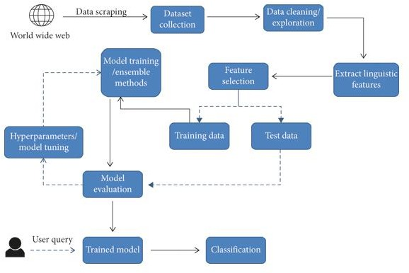

Fig 6.1 – System Architecture

DATA FLOW DIAGRAM

A data flow diagram (DFD) is a graphical representation of data through an information system. It is a useful tool for analysing, modelling, and documenting a system’s processes and the flow of data between those processes. DFDs can help you understand the relationships between different components and identify potential bottlenecks or inefficiencies.
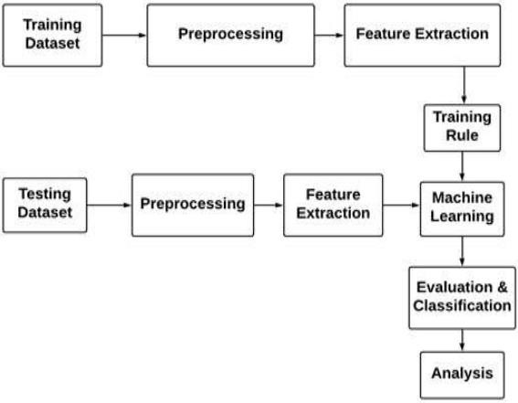

6.2 Data Flow Diagram

UML DIAGRAM

A UML diagram is a diagram based on the UML (Unified Modelling Language) with the purpose of visually representing a system along with its main actors, roles, actions, artefacts or classes, in order to better understand, alter, maintain, or document information about the system. It is based on diagrammatic representations of software components.

USE CASE DIAGRAM

A use case diagram is a type of UML diagram that illustrates the interactions between actors (users or other systems) and system or application. It represents the functionality of the system and the specific tasks or actions that can be perform by the actors. Use case diagram are useful for identifying the requirements of a system, defining the scope of a project, and communicating thefunctionality of a system to stakeholders.
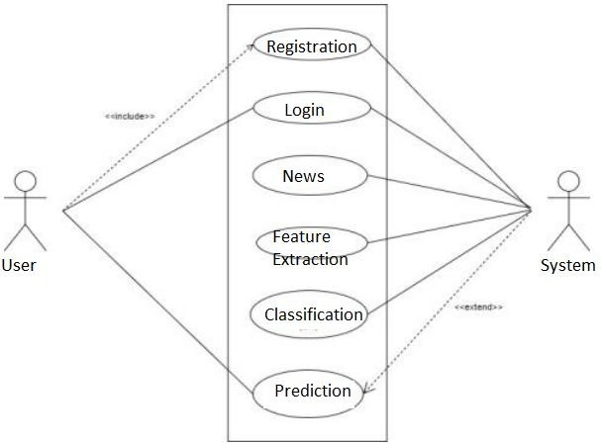

    - Use Case Diagram

CLASS DIAGRAM

A class diagram in the unified modelling language (UML) is a type of static structure diagram that describes the structure of a system by showing a system’sclasses, their attributes operations (or methods), and the relationships among objects. The class diagram is the main building block of object oriented modeling of the systematic of the applications, and for detailed modeling translating the models into programming code. Class diagram can also be used for data modeling. The classes in a class diagram represent boy the main elements, interactions in the applications, and the classes to be programmed.
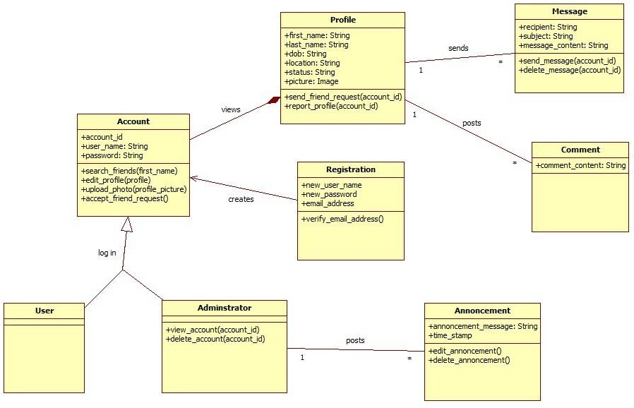

    - Class Diagram

SEQUENCE DIAGRAM

A sequence diagram is an interaction diagram that shows how objects operate with one another and in what order. It is a construct of a message sequence chart. A sequence diagram shows object interactions arranged in time sequence. It depicts the objects and classes involved in the scenario and the sequence of messages exchanged between the objects needed to carry out the functionality of the scenario. Sequence diagrams are typically associated with use case realizations in the logical view of the system under development. Sequence diagrams are sometimes called event diagrams or event scenarios.
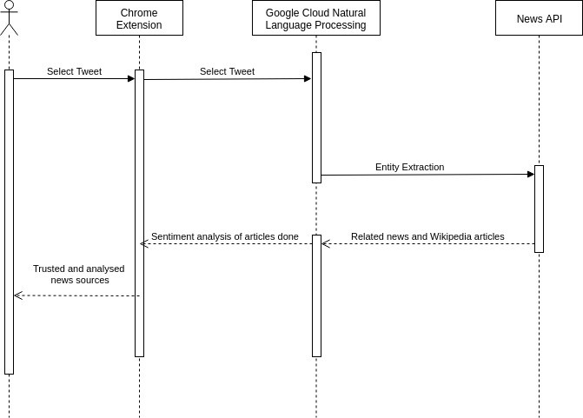

    - Sequence Diagram

ACTIVITY DIAGRAM

Activity diagrams show the workflow from a start point to the finish point detailing the many decision paths that exist in the progression of events contained in the activity. They may be used to detail situations where parallel processing may occur in the execution of some activities.

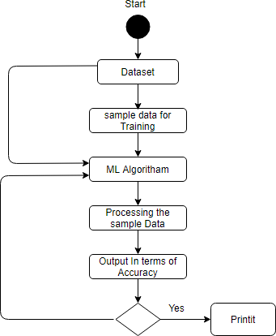

    - Activity Diagram

CHAPTER - 7

SOFTWARE DESCRIPTION

  - FRONT END

Python
Python is a high-level, interpreted, interactive and object-oriented scripting language. Python is designed to be highly readable. It uses English keywords frequently where as other languages use punctuation, and it has fewer syntactical constructions than other languages.
Python is Interpreted − Python is processed at runtime by the interpreter. You do not need to compile your program before executing it. This is similar to PERL and PHP.
Python is Interactive − You can actually sit at a Python prompt and interact with the interpreter directly to write your programs.
Python is Object-Oriented − Python supports Object-Oriented style or technique of programming that encapsulates code within objects.
Python is a Beginner's Language − Python is a great language for the beginner-level programmers and supports the development of a wide range of applications from simple text processing to WWW browsers to games.
Python is an open-source and cross-platform programming language. It is available for use under Python Software Foundation License (compatible to GNU General Public License) on all the major operating system platforms Linux, Windows and Mac OS.To facilitate new features and to maintain that readability, the Python Enhancement Proposal (PEP) process was developed. This process allows anyone to submit a PEP for a new feature, library, or other addition.
The design philosophy of Python emphasizes on simplicity, readability and unambiguity. Python is known for its batteries included approach as Python software is distributed with a comprehensive standard library of functions and modules.
Python's design philosophy is documented in the Zen of Python. It consists of nineteen aphorisms such as −
Beautiful is better than ugly Explicit is better than implicit Simple is better than complex Complex is better than complicated
To obtain the complete Zen of Python document, type import this in the Python Shell −

>>>import this
This will produce following 19 aphorisms - Beautiful is better than ugly.
Explicit is better than implicit. Simple is better than complex. Complex is better than complicated. Flat is better than nested.
Sparse is better than dense. Readability counts.
Special cases aren't special enough to break the rules. Although practicality beats purity.
Errors should never pass silently. Unless explicitly silenced.
In the face of ambiguity, refuse the temptation to guess.
There should be one-- and preferably only one --obvious way to do it. Although that way may not be obvious at first unless you're Dutch.
Now is better than never.
Although never is often better than *right* now.
If the implementation is hard to explain, it's a bad idea.
If the implementation is easy to explain, it may be a good idea. Namespaces are one honking great idea -- let's do more of those!
Python supports imperative, structured as well as object-oriented programming methodology. It provides features of functional programming as well.
Pythonic Code Style
Python leaves you free to choose to program in an object-oriented, procedural, functional, aspect-oriented, or even logic-oriented way. These freedoms make Python a great language to write clean and beautiful code.
Pythonic Code Style is actually more of a design philosophy and suggests to write a code which is :
Clean Simple Beautiful Explicit Readable

The Zen of Python
The Zen of Python is about code that not only works, but is Pythonic. Pythonic code is readable, concise, and maintainable.
History of Python
Python was developed by Guido van Rossum in the late eighties and early nineties at the National Research Institute for Mathematics and Computer Science in the Netherlands.
Python is derived from many other languages, including ABC, Modula-3, C, C++, Algol- 68, SmallTalk, and Unix shell and other scripting languages.
Python is copyrighted. Like Perl, Python source code is now available under the GNU General Public License (GPL).
For many uninitiated people, the word Python is related to a species of snake. Rossum though attributes the choice of the name Python to a popular comedy series Monty Python's Flying Circus on BBC.
Being the principal architect of Python, the developer community conferred upon him the title of Benevolent Dictator for Life (BDFL). However, in 2018, Rossum relinquished the title. Thereafter, the development and distribution of the reference implementation of Python is handled by a nonprofit organization Python Software Foundation.
Who Invented Python?
Python was invented by a Dutch Programmer Guido Van Rossum in the late 1980s. And, Python's first version (0.9.0) was released in 1991.
Evolution of Python – The Major Python Releases Following are the important stages in the history of Python − Python 0.9.0
Python's first published version is 0.9. It was released in February 1991. It consisted of support for core object-oriented programming principles.
Python 1.0
In January 1994, version 1.0 was released, armed with functional programming tools, features like support for complex numbers etc.
Python 2.0
Next major version − Python 2.0 was launched in October 2000. Many new features such as list comprehension, garbage collection and Unicode support were included with it.
Python 3.0
Python 3.0, a completely revamped version of Python was released in December 2008. The primary objective of this revamp was to remove a lot of discrepancies that had crept

in Python 2.x versions. Python 3 was backported to Python 2.6. It also included a utility named as python2to3 to facilitate automatic translation of Python 2 code to Python 3.
EOL for Python 2.x
Even after the release of Python 3, Python Software Foundation continued to support the Python 2 branch with incremental micro versions till 2019. However, it decided to discontinue the support by the end of year 2020, at which time Python 2.7.17 was the last version in the branch.
Current Version of Python
Meanwhile, more and more features have been incorporated into Python's 3.x branch. As of date, Python 3.11.2 is the current stable version, released in February 2023.
Python is a feature rich high-level, interpreted, interactive and object-oriented scripting language. This tutorial will list down some of the important features of Python:
Features of Python
Let's highlight some of the important features of Python that make it widely popular. Apart from these 10 features where are number of other interesting features which make Python most of the developer's first choice.
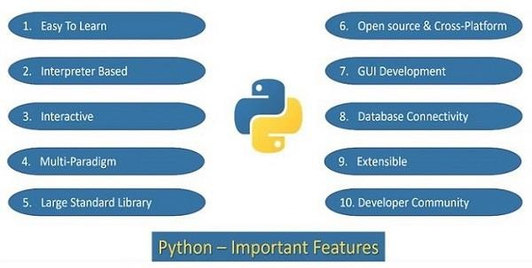
The following are the features of Python programming language –
- Easy to Learn
This is one of the most important reasons for the popularity of Python. Python has a limited set of keywords. Its features such as simple syntax, usage of indentation to avoid clutter of curly brackets and dynamic typing that doesn't necessitate prior declaration of variable help a beginner to learn Python quickly and easily.

- Interpreter Based
Instructions in any programming languages must be translated into machine code for the processor to execute them. Programming languages are either compiler based or interpreter based.
In case of a compiler, a machine language version of the entire source program is generated. The conversion fails even if there is a single erroneous statement. Hence, the development process is tedious for the beginners. The C family languages (including C, C++, Java, C# etc) are compiler based.
Python is an interpreter based language. The interpreter takes one instruction from the source code at a time, translates it into machine code and executes it. Instructions before the first occurrence of error are executed. With this feature, it is easier to debug the program and thus proves useful for the beginner level programmer to gain confidence gradually. Python therefore is a beginner-friendly language.
- Interactive
Standard Python distribution comes with an interactive shell that works on the principle of REPL (Read – Evaluate – Print – Loop). The shell presents a Python prompt >>>. You can type any valid Python expression and press Enter. Python interpreter immediately returns the response and the prompt comes back to read the next expression.
>>> 2*3+1 7
>>> print ("Hello World") Hello World
The interactive mode is especially useful to get familiar with a library and test out its functionality. You can try out small code snippets in interactive mode before writing a program.
- MultiParadigm
Python is a completely object-oriented language. Everything in a Python program is an object. However, Python conveniently encapsulates its object orientation to be used as an imperative or procedural language – such as C. Python also provides certain functionality that resembles functional programming. Moreover, certain third-party tools have been developed to support other programming paradigms such as aspect-oriented and logic programming.
- Standard Library

Even though it has a very few keywords (only Thirty Five), Python software is distributed with a standard library made of large number of modules and packages. Thus Python has out of box support for programming needs such as serialization, data compression, internet data handling, and many more. Python is known for its batteries included approach.
- Open Source and Cross Platform
Python's standard distribution can be downloaded from https://www.python.org/downloads/ without any restrictions. You can download pre- compiled binaries for various operating system platforms. In addition, the source code is also freely available, which is why it comes under open source category.
Python software (along with the documentation) is distributed under Python Software Foundation License. It is a BSD style permissive software license and compatible to GNU GPL (General Public License).
Python is a cross-platform language. Pre-compiled binaries are available for use on various operating system platforms such as Windows, Linux, Mac OS, Android OS. The reference implementation of Python is called CPython and is written in C. You can download the source code and compile it for your OS platform.
A Python program is first compiled to an intermediate platform independent byte code. The virtual machine inside the interpreter then executes the byte code. This behaviour makes Python a cross-platform language, and thus a Python program can be easily ported from one OS platform to other.
- GUI Applications
Python's standard distribution has an excellent graphics library called TKinter. It is a Python port for the vastly popular GUI toolkit called TCL/Tk. You can build attractive user-friendly GUI applications in Python. GUI toolkits are generally written in C/C++. Many of them have been ported to Python. Examples are PyQt, WxWidgets, PySimpleGUI etc.
- Database Connectivity
Almost any type of database can be used as a backend with the Python application. DB- API is a set of specifications for database driver software to let Python communicate with a relational database. With many third party libraries, Python can also work with NoSQL databases such as MongoDB.
- Extensible

The term extensibility implies the ability to add new features or modify existing features. As stated earlier, CPython (which is Python's reference implementation) is written in C. Hence one can easily write modules/libraries in C and incorporate them in the standard library. There are other implementations of Python such as Jython (written in Java) and IPython (written in C#). Hence, it is possible to write and merge new functionality in these implementations with Java and C# respectively.
- Active Developer Community
As a result of Python's popularity and open-source nature, a large number of Python developers often interact with online forums and conferences. Python Software Foundation also has a significant member base, involved in the organization's mission to "Promote, Protect, and Advance the Python Programming Language"
Python also enjoys a significant institutional support. Major IT companies Google, Microsoft, and Meta contribute immensely by preparing documentation and other resources.

BACK END

Dataset

Dataset is essentially the backbone for all operations, techniques or models used by developers to interpret them. Datasets involve a large amount of data points grouped into one table. Datasets are used in almost all industries today for various reasons. In this day and age, to train the younger generation to interact effectively with Datasets, many Universities publicly release their Datasets for example UCI and websites like Kaggle and even GitHub release datasets which developers can work with to get the necessary outputs.
A Dataset is a set of data grouped into a collection with which developers can work to meet their goals. In a dataset, the rows represent the number of data points and the columns represent the features of the Dataset. They are mostly used in fields like machine learning, business, and government to gain insights, make informed decisions, or train algorithms. Datasets may vary in size and complexity and they mostly require cleaning and pre-processing to ensure data quality and suitability for analysis or modelling.
Let us see an example below:

Dataset

This is the Iris dataset. Since this is a dataset with which we build models, there are input features and output features. Here:
The input features are Sepal Length, Sepal Width, Petal Length, and Petal Width. Species is the output feature.
Datasets can be stored in multiple formats. The most common ones are CSV, Excel, JSON, and zip files for large datasets such as image datasets.
Types of Datasets

There are various types of datasets available out there. They are:

Numerical Dataset: They include numerical data points that can be solved with equations. These include temperature, humidity, marks and so on.

Categorical Dataset: These include categories such as colour, gender, occupation, games, sports and so on.
Web Dataset: These include datasets created by calling APIs using HTTP requests and populating them with values for data analysis. These are mostly stored in JSON (JavaScript Object Notation) formats.
Time series Dataset: These include datasets between a period, for example, changes in geographical terrain over time.
Image Dataset: It includes a dataset consisting of images. This is mostly used to differentiate the types of diseases, heart conditions and so on.
Ordered Dataset: These datasets contain data that are ordered in ranks, for example, customer reviews, movie ratings and so on.
Partitioned Dataset: These datasets have data points segregated into different members or different partitions.
File-Based Datasets: These datasets are stored in files, in Excel as .csv, or .xlsx files.

Bivariate Dataset: In this dataset, 2 classes or features are directly correlated to each other. For example, height and weight in a dataset are directly related to each other.
Multivariate Dataset: In these types of datasets, as the name suggests 2 or more classes are directly correlated to each other. For example, attendance, and assignment grades are directly correlated to a student’s overall grade.
Features of a Dataset

The features of a dataset may allude to the columns available in the dataset. The features of a dataset are the most critical aspect of the dataset, as based on the features of each available data point, will there be any possibility of deploying models to find the output to predict the features of any new data point that may be added to the dataset.
It is only possible to determine the standard features from some datasets since their functionalities and data would be completely different when compared to other datasets. Some possible features of a dataset are:

Numerical Features: These may include numerical values such as height, weight, and so on. These may be continuous over an interval, or discrete variables.
Categorical Features: These include multiple classes/ categories, such as gender, colour, and so on.
Metadata: Includes a general description of a dataset. Generally in very large datasets, having an idea/ description of the dataset when it’s transferred to a new developer will save a lot of time and improve efficiency.
Size of the Data: It refers to the number of entries and features it contains in the file containing the Dataset.
Formatting of Data: The datasets available online are available in several formats. Some of them are JSON (JavaScript Object Notation), CSV (Comma Separated Value), XML (eXtensible Markup Language), DataFrame, and Excel Files (xlsx or xlsm). For particularly large datasets, especially involving images for disease detection, while downloading the files from the internet, it comes in zip files which will be needed to extract in the system to individual components.
Target Variable: It is the feature whose values/attributes are referred to to get outputs from the other features with machine learning techniques.
Data Entries: These refer to the individual values of data present in the Dataset. They play a huge role in data analysis.
SQL is a language to operate databases; it includes database creation, deletion, fetching rows, modifying rows, etc. SQL is an ANSI (American National Standards Institute) standard language, but there are many different versions of the SQL language.
What is SQL?

SQL is Structured Query Language, which is a computer language for storing, manipulating and retrieving data stored in a relational database.
SQL is the standard language for Relational Database System. All the Relational Database Management Systems (RDMS) like MySQL, MS Access, Oracle, Sybase, Informix, Postgres and SQL Server use SQL as their standard database language.

Also, they are using different dialects, such as −

- MS SQL Server using T-SQL,
- Oracle using PL/SQL,
- MS Access version of SQL is called JET SQL (native format) etc.

Why SQL?

SQL is widely popular because it offers the following advantages −

- Allows users to access data in the relational database management systems.
- Allows users to describe the data.
- Allows users to define the data in a database and manipulate that data.
- Allows embedding within other languages using SQL modules, libraries & pre- compilers.
- Allows users to create and drop databases and tables.
- Allows users to create view, stored procedure, functions in a database
Structured Query Language (SQL) is a standardized programming language that is used to manage relational databases and perform various operations on the data in them. Initially created in the 1970s, SQL is regularly used not only by database administrators, but also by developers writing data integration scripts and data analysts looking to set up and run analytical queries.
The term SQL is pronounced ess-kew-ell or sequel. SQL is used for the following:
Modifying database table and index structures; Adding, updating and deleting rows of data; and
Retrieving subsets of information from within relational database management systems (RDBM Ses) -- this information can be used for transaction processing, analytics applications and other applications that require communicating with a relational database. SQL queries and other operations take the form of commands written as statements and are aggregated into programs that enable users to add, modify or retrieve data from database tables.

A table is the most basic unit of a database and consists of rows and columns of data. A single table holds records, and each record is stored in a row of the table. Tables are the most used type of database objects, or structures that hold or reference data in a relational database. Other types of database objects include the following:
Views are logical representations of data assembled from one or more database tables. Indexes are lookup tables that help speed up database lookup functions.
Reports consist of data retrieved from one or more tables, usually a subset of that data that is selected based on search criteria.
Each column in a table corresponds to a category of data -- for example, customer name or address -- while each row contains a data value for the intersecting column.
Relational databases are relational because they are composed of tables that relate to each other. For example, a SQL database used for customer service can have one table for customer names and addresses and other tables that hold information about specific purchases, product codes and customer contacts. A table used to track customer contacts usually uses a unique customer identifier called a key or primary key to reference the customer's record in a separate table used to store customer data, such as name and contact information.
SQL became the de facto standard programming language for relational databases after they emerged in the late 1970s and early 1980s.
Relational vs. nonrelational databases

The SQL query language can be used for relational or nonrelational databases, but it offers advantages for relational databases.
SQL standard and proprietary extensions

An official SQL standard was adopted by the American National Standards Institute (ANSI) in 1986, with the International Organization for Standardization (ISO) adopting the standard in 1987. New versions of the SQL standard are published every few years, the most recent in 2016.

ISO/IEC 9075 is the ISO SQL standard developed jointly by ISO and the International Electro technical Commission. The standard way of referring to an ISO standard version is to use the standards organizations -- ISO/IEC -- followed by the ISO standard number, a colon and the publication year. The current ISO standard for SQL is ISO/IEC 9075:2016.
Both proprietary and open source RDBMSes built around SQL are available for use by organizations. SQL-compliant database server products include the following:
Microsoft SQL Server Oracle Database
IBM Db2 SAP HANA
SAP Adaptive Server Oracle MySQL
open source postgreSQL

Some versions of SQL include proprietary extensions to the standard language for procedural programming and other functions. For example, Microsoft offers a set of extensions called Transact-SQL, while Oracle's extended version of the standard is Procedural Language for SQL. Commercial vendors offer proprietary extensions to differentiate their product offerings by giving customers additional features and functions. As a result, the different variants of extended SQL offered by vendors are not fully compatible with one another.
SQL commands and syntax

SQL is, fundamentally, a programming language designed for accessing, modifying and extracting information from relational databases. As a programming language, SQL has commands and a syntax for issuing those commands.
SQL commands are divided into several different types, including the following:

Data Definition Language (DDL) commands are also called data definition commands because they are used to define data tables.
Data Manipulation Language (DML) commands are used to manipulate data in existing tables by adding, changing or removing data. Unlike DDL commands that define how data is stored, DML commands operate in the tables defined with DDL commands.
Data Query Language consists of just one command, SELECT, used to get specific data from tables. This command is sometimes grouped with the DML commands.
Data Control Language commands are used to grant or revoke user access privileges.

Transaction Control Language commands are used to change the state of some data -- for example, to COMMIT transaction changes or to ROLLBACK transaction changes.
SQL syntax, the set of rules for how SQL statements are written and formatted, is similar to other programming languages. Some components of SQL syntax include the following:
SQL statements start with a SQL command and end with a semicolon (;), for example: SELECT * FROM customers;
This SELECT statement extracts all of the contents of a table called customers.

SQL statements are case-insensitive, meaning that they can be written using lowercase, uppercase or a combination. However, it is customary to write out SQL keywords -- commands or control operators -- in all-caps and table/column names in lowercase. Words in the statement can be treated as case-sensitive using quotes, so the following two statements produce identical results.
SELECT * FROM customers; select * from CUSTOMERS; These two statements are different: SELECT * FROM customers; SELECT * FROM "Customers";

SQL statements are terminated only by the semicolon, meaning that more complex statements can be rendered across multiple lines, like this one:
SELECT name, telephone, age FROM customers;
This command selects the contents of the columns name, telephone and age in the table customers.
SQL statements can incorporate program flow controls, meaning that a statement can incorporate table and row selection -- as in the previous example -- and then operate on the data contained in those columns. For example, the following command selects the name, telephone number and birthdate for all customers whose age is over 21:
SELECT name, telephone, age FROM customers
WHERE age > 21;

Most SQL implementations include support for issuing statements at the command line, through a graphical user interface, by using SQL programs or through application programming interfaces to access SQL databases using other programming languages.
Commonly used SQL commands with examples

Most SQL commands are used with operators to modify or reduce the scope of data operated on by the statement. Some commonly used SQL commands, along with examples of SQL statements using those commands, follow.
SQL SELECT. The SELECT command is used to get some or all data in a table. SELECT can be used with operators to narrow down the amount of data selected:
SELECT title, author, pub_date FROM catalog
WHERE pub_date = 2021;

This example could be used by a publisher to select the title, author and publication date columns from a table named catalog.
SQL CREATE. The CREATE command is used to create a new SQL database or SQL table. Most versions of SQL create a new database by creating a new directory, in which tables and other database objects are stored as files.
The following CREATE DATABASE statement creates a new SQL database named Human_Resources:
CREATE DATABASE Human_Resources;

The CREATE TABLE command is used create a table in SQL. The following statement creates a table named Employees that has three columns: employee_ID, last_name and first_name, with the first column storing integer (int) data and the other columns storing variable character data of type varchar and a maximum of 255 characters.
CREATE TABLE Employees ( employee_ID int,
last_name varchar(255), first_name varchar(255)
);

SQL DELETE. The DELETE command removes rows from a named table. In this example, all records of employees with the last name Smithee are deleted:
DELETE FROM Employees WHERE last_name='Smithee';

This statement returns the number of rows deleted when it finishes running.

SQL INSERT INTO. The INSERT INTO command is used to add records into a database table. The following statement adds a new record into the Employees table:
INSERT INTO Employees ( last_name,
first_name

)

VALUES (

'Alan', 'Smithee'
);

SQL UPDATE. The UPDATE command is used to make changes to rows or records in a specific table. For example, the following statement updates all records that include a last_name value of Smithee by changing the name to Smith:
UPDATE Employees SET last_name = 'Smith',
WHERE last_name = 'Smithee';

SQL statements can use loops, variables and other components of a programming language to update records based on different criteria.
SQL-on-Hadoop tools

SQL-on-Hadoop query engines are a newer offshoot of SQL that enable organizations with big data architectures built around Hadoop data stores to use SQL as a querying language and enable database professionals to use a familiar query language instead of having to use more complex and less familiar languages -- in particular, the MapReduce programming environment for developing batch processing applications.
More than a dozen SQL-on-Hadoop tools are available from Hadoop distribution providers and other vendors; many of them are open source software or commercial versions. In addition, the Apache Spark processing engine, which is often used in conjunction with Hadoop, includes a Spark SQL module that similarly supports SQL- based programming.
Not all SQL-on-Hadoop tools support all of the functionality offered in relational implementations of SQL. But SQL-on-Hadoop tools are a regular component of Hadoop

deployments, as companies look to get developers and data analysts with SQL skills involved in programming big data applications.
SQL security

SQL servers are subject to most of the same vulnerabilities as any other enterprise application, including weak authentication, insecure design, misconfiguration and other application security issues. However, SQL injection, first reported in 1998, continues to dominate security issues for SQL systems.
SQL injection attacks usually exploit weaknesses in systems where data submissions are not scanned and sanitized to remove potentially malicious code incorporated or injected into data.
The best-known example of a SQL injection exploit is documented in the "Little Bobby Tables" comic by Randall Munroe, in which a SQL injection is perpetrated by a mom who filled out a SQL form with her son's name followed by malicious SQL code.
In the comic, the son's name is entered as the following:

Robert'); DROP TABLE Students; --

Following the valid data (Robert), the name continues with characters that SQL servers interpret as ending the data -- single quote, close parenthesis and semicolon -- followed by the DROP TABLE command.
Use of best practices for database security can help protect an organization's most valuable digital assets.
History of SQL

With roots going back to the early 1970s, SQL continues to make key milestones in history as one of the most successful ideas in computing history.
1970. "A Relational Model of Data for Large Shared Data Banks" by E.F. Codd publishes in Communications of the ACM, laying the basis for RDBMSes.
1974. IBM researchers publish an article introducing Structured Query Language, first called SEQUEL or Structured English Query Language. The name was changed for trademark purposes.

1977. Relational Software Inc., the company that eventually became Oracle, begins building a commercial RDBMS.
1979. Oracle ships first commercially available RDBMS for Digital Equipment Corp.'s minicomputer systems.
1982. IBM ships SQL/Data System, a SQL RDBMS for IBM mainframes.

1985. IBM ships Database 2, a SQL RDBMS for IBM's Multiple Virtual Storage mainframe operating system.
1986. An ANSI committee and then ISO adopt SQL as a standard. 1989. First revision of the ISO SQL standard, SQL-89, publishes. 1992. First major revision of ISQ SQL standard, SQL-92, publishes.
1999. First version to be named in accordance with ISO naming standards, ISO/IEC SQL:1999, adds programming functionality and support for Java.
2003. ISO/IEC SQL:2003 adds support for a predefined data type for Extensible Markup Language (XML) objects.
2006. ISO/IEC SQL:2006 expands XML-related functionality.

2008. ISO/IEC SQL:2008 adds support for partitioned JOINs, a method for linking two or more tables that treats the joined tables as a single table.
2011. ISO/IEC SQL:2011 improves support for relational databases containing time- related data.
2016. ISO/IEC SQL:2016 adds optional new features, including JavaScript Object Notation-related changes, support for polymorphic table functions and row pattern matching.

CHAPTER - 8

SYSTEM TESTING

  - TESTING PROCESS

Testing is performed to identify errors. It is used for quality assurance. Testing is an integral part of the entire development and maintenance process. The goal of the testing during phase is to verify that the specification has been accurately and completely incorporated into the design, as well as to ensure the correctness of the design itself. For example the design must not have any logic faults in the design is detected before coding commences, otherwise the cost of fixing the faults will be considerably higher as reflected. Detection of design faults can be achieved by means of inspection as well as walkthrough.
Testing is one of the important steps in the software development phase. Testing checks for the errors, as a whole of the project testing involves the following test cases:
    - Static analysis is used to investigate the structural properties of the Source code.
    - Dynamic testing is used to investigate the behaviour of the source code by executing the program on the test data.

TYPES OF TESTING

UNIT TESTING:
Unit testing is conducted to verify the functional performance of each modular component of the software. Unit testing focuses on the smallest unit of the software design (i.e.), the module. The white-box testing techniques were heavily employed for unit testing.

FUNCTIONAL TESTS:
Functional test cases involved exercising the code with nominal input values for which the expected results are known, as well as boundary values and special values, such as logically related inputs, files of identical elements, and empty files.
Three types of tests in Functional test:
- Performance Test
- Stress Test

- Structure Test

PERFORMANCE TEST:
It determines the amount of execution time spent in various parts of the unit, program throughput, and response time and device utilization by the program unit.

STRESS TEST:
Stress Test is those test designed to intentionally break the unit. A Great dealcan be learned about the strength and limitations of a program by examining the manner in which a programmer in which a program unit breaks.

INTEGRATION TESTING:
Integration testing is a systematic technique for construction the program structure while at the same time conducting tests to uncover errors associated with interfacing. i.e., integration testing is the complete testing of the set of modules which makes up the product. The objective is to take untested modules and build a program structure tester should identify critical modules. Critical modules should be tested as early as possible. One approach is to wait until all the units have passed testing, and then combine them and then tested. This approach is evolved from unstructured testing of small programs. Another strategy is to construct the product in increments of tested units. A small set of modules are integrated together and tested, to which another module is added and tested in combination. And so on. The advantages of this approach are that, interface dispenses can be easily found and corrected. The major error that was faced during the project is linking error. When all the modules are combined the link is not set properly with all support files. 41 Then we checked out for interconnection and the links. Errors are localized to the new module and its intercommunications. The product development can be staged, and modules integrated in as they complete unit testing. Testing is completed when the last module is integrated and tested.

TESTING TECHNIQUES / TESTING STRATERGIES TESTING:
Testing is a process of executing a program with the intent of finding an error. A good test case is one that has a high probability of finding an as-yet – undiscovered error. A successful test is one that uncovers an as-yet- undiscovered error. System testing is the stage of implementation, which is aimed at ensuringthat the system works accurately and efficiently as expected before live operation commences. It verifies that the whole set of programs hang together. System testing requires a test consists of several key activities

and steps for run program, string, system and is important in adopting a successful new system. This is the lastchance to detect and correct errors before the system is installed for user acceptance testing. The software testing process commences once the program is created and the documentation and related data structures are designed. Software testing is essential for correcting errors. Otherwise the program or the project is not said to be complete. Software testing is the critical element of software quality assurance and represents the ultimate the review of specification design and coding. Testing is the process of executing the program with the intent of finding the error. A good test case design is one that as a probability of finding an yet undiscovered error. A successful test is one that uncovers an yet undiscovered error. Any engineering product can be tested in one of the two ways

WHITE BOX TESTING:
This testing is also called as Glass box testing. In this testing, by knowingthe specific functions that a product has been design to perform test can be conducted that demonstrate each function is fully operational at the same time searching for errors in each function. It is a test case design method that uses the control structure of the procedural design to derive test cases. Basis path testing isa white box testing.
Basis path testing:
- Flow graph notation

- Cyclometric complexity

- Deriving test cases
- Graph matrices Control

BLACK BOX TESTING:
In this testing by knowing the internal operation of a product, test can be conducted to ensure that “all gears mesh”, that is the internal operation performs according to specification and all internal components have been adequately exercised. It fundamentally focuses on the functional requirements of the software.
The steps involved in black box test case design are:
- Graph based testing methods
- Equivalence partitioning

- Boundary value analysis
- Comparison testing

SOFTWARE TESTING STRATEGIES:
A software testing strategy provides a road map for the software developer. Testing is a set activity that can be planned in advance and conducted systematically. For this reason a template for software testing a set of steps into which we can place specific test case design methods should be strategy should have the following characteristics:
- Testing begins at the module level and works “outward” toward the integration of the entire computer based system.
- Different testing techniques are appropriate at different points in time.
- The developer of the software and an independent test group conductstesting.
- Testing and Debugging are different activities but debugging must be accommodated in any testing strategy.

INTEGRATION TESTING:
Integration testing is a systematic technique for constructing the program structure while at the same time conducting tests to uncover errors associated with. Individual modules, which are highly prone to interface errors, should not be assumed to work instantly when we put them together. The problem of course, is “putting them together”- interfacing. There may be the chances of data lost across on another’s sub functions, when combined may not produce the desired major function; individually acceptable impression may be magnified to unacceptable levels; global data structures can present problems.

PROGRAM TESTING:
The logical and syntax errors have been pointed out by program testing. A syntax error is an error in a program statement that in violates one or more rules of the language in which it is written. An improperly defined field dimension omitted keywords are common syntax error. These errors are shown through error messages generated by the computer. A logic error on the other hand deals with the incorrect data fields, out-off- range items and invalid combinations. Since the compiler s will not deduct logical error,

the programmer must examine the output. Condition testing exercises the logical conditions contained in a module. The possible types of elements in a condition include a Boolean operator, Boolean variable, a pair of Boolean parentheses A relational operator or on arithmetic expression. Condition testing method focuses on testing each condition in the program the purpose of condition test is to deduct not only errors in the condition of a program but also other a errors in the program.

SECURITY TESTING:
Security testing attempts to verify the protection mechanisms built in to a system well, in fact, protect it from improper penetration. The system security mustbe tested for invulnerability from frontal attack must also be tested for invulnerability from rear attack. During security, the tester places the role of individual who desires to penetrate system.

VALIDATION TESTING:
At the culmination of integration testing, software is completely assembled as a package. Interfacing errors have been uncovered and corrected and a final series of software test-validation testing begins. Validation testing can be defined in many ways, but a simple definition is that validation succeeds when the software functions in manner that is reasonably expected by the customer. Software validation is achieved through a series of black box tests that demonstrate conformity with requirement. After validation test has been conducted, one of two conditions exists.
- The function or performance characteristics confirm to specifications and are accepted.
- A validation from specification is uncovered and a deficiency created.
Deviation or errors discovered at this step in this project is corrected prior to completion of the project with the help of the user by negotiating to establish a method for resolving deficiencies. Thus the proposed system under consideration has been tested by using validation testing and found to be working satisfactorily. Though there were deficiencies in the system they were not catastrophic.

USER ACCEPTANCE TESTING:
User acceptance of the system is key factor for the success of any system. The system under consideration is tested for user acceptance by constantly keeping in touch with prospective system and user at the time of developing and making change.

CHAPTER - 9

CONCLUSION & FUTURE ENHANCEMENT

  - CONCLUSION

A user interface is built and linked to a machine learning model that has been trained. A Passive Aggressive Classifier with j48 algorithm is trained and used to predict user-inputted news. Users may submit news into this platform, and it will determine if the article is true or not.. The method proposed performed better than those accepted for the three approaches. Using that proposed approach, the accuracy, retrieval, and error of recognition were enhanced. The reason for the move was that it scrapped some redundant functions which did not provide gender reparability. The proposed method abused characteristics that were not recognized by the three chosen approaches. The proposed system describes a personalized based news recommendation from social media. The online news population dataset also available on machine learning UCI repository.

FUTURE ENHANCEMENT

During the initial research process, the system's output is assessed using this dataset, and accuracy is calculated. However, there is still room for development by introducing a hybrid model that uses a range of feature selection approaches.

APPENDICES APPENDIX 1 – SOURCE CODE
import pickle
from flask import Flask, request, render_template

app = Flask( name )
model = pickle.load(open('pac.pkl', 'rb')) vectorizer = pickle.load(open('vectorizer.pkl','rb'))

@app.route('/') def home():
return render_template('home.html')

@app.route('/predict',methods=['POST']) def predict():
if request.method == 'POST':
news = request.form['news'] data = [news]
vect = vectorizer.transform(data) my_prediction = model.predict(vect)
return render_template('prediction.html', prediction=my_prediction)

if name == ' main ': app.run(debug=True)

Home.html:
<!DOCTYPE html>
<html>
<head>
<title>Rumor Detection</title>

<meta name="viewport" content="width=device-width, initial-scale=1.0">
<link href="https://fonts.googleapis.com/css?family=Roboto:300,400,500,700" rel="stylesheet">
<link rel="stylesheet" href="https://use.fontawesome.com/releases/v5.5.0/css/all.css" integrity="sha384- B4dIYHKNBt8Bc12p+WXckhzcICo0wtJAoU8YZTY5qE0Id1GSseTk6S+L3BlXeVIU" crossorigin="anonymous">
<style> html, body {
min-height: 100vh; margin:0px;
}
body, div, form, p { padding: 0;
margin: 0; outline: none;
font-family: Roboto, Arial, sans-serif; font-size: 14px;
color: #666;
line-height: 22px;
}

h1
{
font-weight: 400;
}

h4
{
margin-bottom: 4px;
}

form
{

padding: 20px; background: #fff;
box-shadow: 0 2px 5px #ccc;
}

textarea
{
width: 75%; display: block; margin-left: auto; margin-right: auto;
margin-bottom: 10px; border: 1px solid #ccc; border-radius: 3px;
}

input:hover, textarea:hover, select:hover
{
outline: none;
border: 1px solid #095484;
}

.btn-block
{
margin-top: 20px; text-align: center;
}

button
{
width: 150px; padding: 10px; border: none;
-webkit-border-radius: 5px;

-moz-border-radius: 5px; border-radius: 5px; background-color: red; font-size: 16px;
color: #fff; cursor: pointer;
}

button:hover
{
background-color: green;
}

@media (min-width: 568px)
{
input
{
width: calc(35% - 20px); margin: 0 0 0 8px;
}
select
{
width: calc(50% - 8px); margin: 0 0 10px 8px;
}
}
</style>
</head>
<body>
<div class="testbox">
<form action="{{ url_for('predict') }}" method="POST">
<h1 align="center">Rumor Detector</h1>
<p align="center">Enter your news</p>
<hr/>

</div>

<h4 align="center">Your article</h4>
<textarea rows="10" required placeholder="Enter your article here" name="news" align="center"></textarea>

<div class="btn-block">
<button type="submit" >Detect</button>
</div>

</form>
</div>
</body>
</html>

Prediction.html:
<html>
<head>
<title>Rumor Detection</title>
<meta name="viewport" content="width=device-width, initial-scale=1.0">
<link href="https://fonts.googleapis.com/css?family=Roboto:300,400,500,700" rel="stylesheet">
<link rel="stylesheet" href="https://use.fontawesome.com/releases/v5.5.0/css/all.css" integrity="sha384- B4dIYHKNBt8Bc12p+WXckhzcICo0wtJAoU8YZTY5qE0Id1GSseTk6S+L3BlXeVIU" crossorigin="anonymous">
<style> html, body {
min-height: 100vh; margin:0px;
}
body, div, form, p { padding: 0;

margin: 0; outline: none;
font-family: Roboto, Arial, sans-serif; font-size: 14px;
color: #666;
line-height: 22px;
}

h1
{
font-weight: 400;
}

h4
{
margin-bottom: 4px;
}

form
{
padding: 20px; background: #fff;
box-shadow: 0 2px 5px #ccc;
}

textarea
{
width: 75%; display: block; margin-left: auto; margin-right: auto;
margin-bottom: 10px; border: 1px solid #ccc; border-radius: 3px;

}

input:hover, textarea:hover, select:hover
{
outline: none;
border: 1px solid #095484;
}

.btn-block
{
margin-top: 20px; text-align: center;
}

button
{
width: 150px; padding: 10px; border: none;
-webkit-border-radius: 5px;
-moz-border-radius: 5px; border-radius: 5px; background-color: red; font-size: 16px;
color: #fff; cursor: pointer;
}

button:hover
{
background-color: green;
}

@media (min-width: 568px)

{
input
{
width: calc(35% - 20px); margin: 0 0 0 8px;
}
select
{
width: calc(50% - 8px); margin: 0 0 10px 8px;
}
}
</style>
</head>
<body>
<form>
<fieldset align="center">
<legend>Prediction</legend>
{% if prediction=='FAKE' %}
<h2 style="color:Red;">Prediction: <span class='danger'>This is a Rumor article</span></h2>
{% elif prediction=='REAL' %}
<h2 style="color:Green;">Prediction: <span class='safe'>This is a REAL news article</span></h2>
{% endif %}
<br>
<a href="/">Check Another</a>
</fieldset>
</form>
</body>
</html>

Datasets: http://asesoresvelfit.com/media/datacredito.co/

http://caixa.com.br.fgtsagendesaqueconta.com/consulta8523211/principal.php?seg=11,17, 42,AM,131,5,05,000000,12,11.fgts
http://hissoulreason.com/js/homepage/home/ http://unauthorizd.newebpage.com/webapps/66fbf/ http://133.130.103.10/23/ http://dj00.co.vu/css/?bsoul=Qg@xIHW%//yh/en/?i=34453&amp;i=34453 http://133.130.103.10/21/logar/ http://httpssicredi.esy.es/servico/sicredi/validarclientes/mobi/index.php http://gamesaty.ga/wp-content///yh/en/?i=31416&amp;i=31416 http://luxuryupgradepro.com/ymailNew/ymailNew/ http://133.130.103.10/1/ http://133.130.103.10/24/sicredi/psmlId/31/paneid/index.htm http://smscaixaacesso.hol.es
http://133.130.103.10/7/SIIBC/siwinCtrl.php http://tinyurl.com/kjmmw57 http://wrightlandscapes.org/no/T/Y1.html
http://mautic.eto-cms.ru/themes/goldstar/mtbonline/newmandt/ http://ginatringali.com//al/alibaba21012015/alibaba21012015/666/index.html https://staticmail.000webhostapp.com/
http://umeda.com.br/bba/BOA/home/ http://krishworldwide.com/BackUp/under/js/ayo1/index.html http://yahoo.co.in/email_open_log_pic.php?mid=9f8fd3e2a108a256bff453d09c965c25&a mp;s=a
http://www.avcc.ac.in/fonts/1/wropboxp/login.html http://craig-hallum.ga/sgg/1/login.htm
http://www.verification-mobile-nab.com/cgi/e8e11a52ed442dc4b327eaa2f19c2521/login/ http://verification-mobile-nab.com/cgi/e8e11a52ed442dc4b327eaa2f19c2521/login/ http://www.justpiddlinboutique.com/win/image.htm http://vcsolutionscorp.com/Block/image.htm
http://almasur.com/wp-includes/pomo/docusign17/ http://asesoresvelfit.com/media/cms/datacredito.co/ https://getpeopleplus.com/EserviceMain/irs/ir/index.html https://taeamigo.com/EserviceMain/irs/ir/index.html https://elmundo-latino.com/ir/index.html

http://sociopremiosedescontos.com/cadastro/ http://cartaopremiadosicoob.com
http://ms-0ffice365supportplanquota.us.com0203499083934.elegantvapour.co.uk/0- 009021--
0203499083934.l3992389100283901233232400349902132443940090132/hotmail.login/
client_id=00000002-0000-0ff1-ce00-000000000000&amp;/000- pc.domain/officelogin1.html?run=login_cmd&amp;statuts=f17ca2c829680ada2fec9fc87b c5f606913063b5e3c451761e1f9d5888ada562
http://www.travrica.com/ntime/T/Y1.html http://system-tnc.esy.es/recovery-chekpoint-login.html
http://sandralucashyde.org/login.yahoo/yahoo.com%20[Lastet%20Update]/indexz.html http://alexanderpetricek.com/EserviceMain/irs/ir/index.html http://di15.co.vu/css/?bsoul=P)HdNhwY//yh/en/?i=31416&amp;i=31416 http://sicredisms.ignitiondomain.com/2017/validarclientes/mobi/index.php https://rajspaces.com/EserviceDLAcct/irs/ir/index.html
http://fb-systemapps.esy.es/recovery-chekpoint-login.html
https://signin-activitysupport.helpcenter-supportfraudsignin.com/mpp/signin/f341/ http://www.citadelchurchjax.com/wp- admin/validateowa/owa/WebAdmin/Outlook%20Web%20App.htm http://pradochaui.com.br/criptografado1/index1.php http://simnokomun.lt/upload/omo/newgd2/newgd/moole/index.php http://di11.co.vu/css/?bsoul=znr($Jxd//yh/en/?i=34639&amp;i=34639 http://www.alligator.site/wp-content/wall/gallary/fin/
http://tinyurl.com/le5tcvf http://tinyurl.com/ll59xhm https://tr.im/1e0rQ
https://www.gommetermiche.it/administrator/modules/auth.att.secure/login.htm http://indonesianwonderagate.com/zee/validate.htm?utm_source=tr.im&amp;utm_mediu m=no_referer&amp;utm_campaign=tr.im%2F1e0rQ&amp;utm_content=direct_input http://tinyurl.com/ll59xhm
http://consultafgts.esy.es/home http://www.ultrakoz.com/uploads/files/reloadedatt.net.html http://www.blackabba.com/sign-on/yahoo/Y1.html http://carretroller.com.br/sss/image.htm

https://www.mamujutengahkab.go.id/terasconfig/www.att.net/ http://sandralucashyde.org/login.yahoo/yahoo.com%20[Lastet%20Update]/indexz.html http://extratoinativos.com/Inativos/
http://consultar-fgts.com/1index.php
http://portal-consultafgts.com/caixa.gov.br/pages/inter/index.php http://ni1232966-3.web20.nitrado.hosting/finance/fnce/ http://fgtsliberacao.com/processa.php https://jokextreme.com/irs.return/Payment%20Lookup.html http://fb-safetyhelp.esy.es/recovery-chekpoint-login.html
http://fb-securitypolicy101inc.esy.es/recovery-chekpoint-login.html
http://fb-securityaccountlogincheck808.esy.es/recovery-chekpoint-login.html http://laghaimrevolution.com/sign-on/yahoo/Y1.html
http://settings-acct024631.esy.es/recovery-chekpoint-login.html http://horizongarments.com/Asher/image.htm http://shittyurl.org/5u
http://ni1232966-4.web16.nitrado.hosting/ye/cmbr/ http://system-support-il.hol.es/facebook-security http://ow.ly/IIzC30bBG3c http://caixaservicosonline.epizy.com
http://sandralucashyde.org/login.yahoo/yahoo.com%20%5BLastet%20Update%5D/index z.html http://anniey06l5.myjino.ru/byte/Cookies/Cookies/Pelewura/onlineverifica@tion/Preview
.htm
http://www.supportt-team.com/Confirmed/MyAccount/ https://forms.zohopublic.com/koogee/form/ACTIVATIONFORM/formperma/g51Bb2g53 DaChBA4be0h2kCA_
https://www.surveybuilder.com/s/oFh4R/nav#p/186a0 https://a.doko.moe/vschbi.html
https://forms.zohopublic.com/foolieax/form/VERIFICATIONFROM/formperma/hg_466j HhCK6_6D61K5AC9eA4
http://muththamizh.com/llc/production-llc/ http://cortazarurdaneta.com/chn/5adfd99cf03b06771d81f8b5607f1d7e/ http://chasebankusa.paradisepaymentgold.com/verification/M2908D716C8M54904AC8/c ard.php

http://briut.fruitfuldemo.com/ http://afraniorodriguezrosero.com/wp-admin/themes/pdf/
http://recovery-account-fb.hol.es/facebook-support?fb_count=0&amp;fb_bmpos=_0 https://verification-members.net/webapps/3db39/ https://rajspaces.com/upload/EserviceDLAcct/irs/ir/index.html
http://promocao-sicoob.cf
https://secure-fbpages-notification.com/ https://olcmeapp.com/mko/image.htm http://support-110048480a.esy.es/security.page/
http://lesaventuriersvoyageurs.com/js/paypal-account-confirm http://restauracjagreenpepper.pl//payment/payment/index.php http://scs-network.com/umpi/eba.html https://redux.news/chase/update/ http://cmfidouala.org/jsdhkjhjdf/cgi-bin/image.htm https://olcmeapp.com/lol/image.htm http://livewellprojects.com/bay/T/Y1.html http://attnethelp.webnode.com
https://tinyurl.com/kvuukxs http://ridinghouseindia.com/ywhl/Y%20index.html http://amethystia.com/T/Y1.html http://paialowereasterncherokeenationsc.com/aaaaa/login.htm http://cover-acct06437.esy.es/recovery-chekpoint-login.html http://www.aharsntenetsrelsioncustomizedia.com/domain/indexx.htm http://safety-acct-003342.esy.es/recovery-chekpoint-login.html http://dressesmela.com//kmd/image.htm http://www.sicredisic.com.br
http://31.220.111.56/asdq12/ http://kuswanto.co.id/wp-includes/cs/Indexxatt.htm https://formcrafts.com/a/valaccount
https://mattewfisher1.000webhostapp.com/sal/YAH%21%21./ya2/index.php http://www.singandvoice.com/10405.php http://www.sententia.com.ar/PayPal/get_started/
http://149.56.201.163/nis-card/
http://web-designing-india.org/dpbx/dpbx/index.php

http://54.157.20.99/principal.php http://www.sea.com.sa/images/filetypes/bankofamericam.com.8789373899383mins.rms mrr/index
http://zogheb.com/tooo/index_1.html http://fgtscontasinativas.online/home http://consultasinvativasfgts.com/processa.php http://extratofgtsonline.com/1index.php http://store2.apple.ch.email-
forwarding.webstore.websis.info/sp/79900b0f5b721ddb89396e71eb7fad41/infos.html?itu nes=_connect-run&secure=5540zef1415405412104ef151511d7f84f5ze1f510eec8bd0e http://www.citadelchurchjax.com/wp- admin/data/owa/WebAdmin/Outlook%20Web%20App.htm http://peloclub.com/onlinepdffiles/Adobe/Adobe/property/adobe/index.html https://www.innovi.cc/tos/script/mail.htm?_pageLabel=page_logonform&amp;cmd=LOB
=RBGLogon&amp;secured_page= http://www.momsweetmoms.com/demo2/Dropbox/Dropbox/ http://www.samanesang.com/wp-content/themes/PDF/PDF/login.htm http://store2.apple.ch.email-forwarding.webstore.websis.info/de/ http://suisscards-ch.elecapponline.net/ch-de/suisse/ http://store2.apple.ch.email-forwarding.webstore.websis.info/sp/ http://asa-direct.ru/bitrix/updates/servi/fr/doss/ http://pascasarjana.uniba- bpn.ac.id/administrator/components/com_joomlaupdate/redire.html http://hb.redllink.com/.ars/empresas/login.htm http://hb.redllink.com/.ars/empresas/login.htm?val=true http://xenangdaiduong.com.vn/wp-config/Sign/
http://tizianabeauty.ch/wp-content/plugins/Manage/ar4d65/checking/check/Support/ID-
NUMB389/myaccount/signin/
http://zemindar.lt/wp-content/languages/dpbx/index.php http://www.crielv.com.br/images/start2.php http://www.sagittariusglobal.com//portal/cache/Cielo/ambiente-seguro.php http://www.sagittariusglobal.com//portal/cache/Cielo/index.html https://goo.gl/MMT7sp

http://abuv.com.br/cliente.conectado40/atendimento_pessoa_fisica/criptografado/index1.p hp
http://voetudoazul.serveuser.com/tudoazul/cadastre.php https://www.rustmaster.com.br/ml/next1.php https://www.rustmaster.com.br/ml/
http://30horasdigital.myvnc.com/30horasdigitalmodulodesegurancafeitoparavoce/ http://i-house.se/wp-
trackback/en/?_Email=&amp;cd945f569a0f37a5e9b3c5a3d8a493b9=&amp;cmd=_home &amp;dispatch=6a0e76a814feed56d53162fd43d1e1df44aff9615a951f0dc67e0ce274860d 76
http://prayogispl.in/elisnow/ymail.html http://zdcp.org/iiii/feedback/login.alibaba.com/login.html http://celebrapack.com/dhnl/DHL/DHL/ http://www.hyperbay.net/merchants/controller/tool/www.alibaba.com/alibaba/trade.php?u rl_type=footer_unsub
http://thehotelmanagment.com/Prime/
https://binary-project.com/cha/chase/home/action.php http://abuv.com.br/cliente.conectado33/atendimento_pessoa_fisica/criptografado/index1.p hp
http://cover-acct09964.esy.es/recovery-chekpoint-login.html http://academica.pt/U/mail.htm
http://kalempong-fb01.esy.es/recovery-chekpoint-login.html http://dujanapublicschool.com/b/WellsLINK/WellsLINK/WellsLINK/WellsLINK/Wells LINK/WellsLINK/WellsLINK/WellsLINK/WellsLINK/WellsLINK/WellsLINK/WellsLI NK/index.html http://abuv.com.br/cliente.conectado1/atendimento_pessoa_fisica/criptografado/index1.ph p
http://paialowereasterncherokeenationsc.com/aaaaa/login.htm http://abuv.com.br/1cliente.conectado.jw1/atendimento_pessoa_fisica/criptografado/index 1.php
http://34.201.92.123/indisponivel.php http://149.56.144.216/processa.php http://jose200495fgts.com/processa.php http://34.224.68.176/principal.php

http://consultasaldossl.com http://meusaldos.com
http://fgts-mobile.com/processa.php http://fgts.mobi/processa.php http://aolonlineservices.cba.pl/chase.php
http://caixa.extratofgtsliberados2017.com/consulta8647454/principal.php http://webmailupgrade-001-site1.itempurl.com/webmaster-secure/owa/confirm.php http://scs-network.com/umpi/dba.html
http://shittyurl.org/5q http://ronin.com.pk/hnm/logintoyahoomail.htm http://raik.hub-web.com/proccesing-fbaccountss/login.php http://provoliprints.gr/001/update.html
http://service-info-dk.hol.es/facebook-confirmation http://www.goepsa.com/Old%20Files/yahoo/IDCHECK.html http://tinyurl.com/kbvf6qz http://dh16.co.vu/css//?bsoul=/yh/en/?i=27724&amp;i=27724 http://kontuit-fb01.esy.es/recovery-chekpoint-login.html http://hunmumu.com/str/Ma/
http://ctrl4enviro.com/wp- includes/SimplePie/Content/Type/Caption/Pelewura/onlineverifica@tion/Preview.htm http://wwp-cartasi-titoari-portale-sicreuzza-2017.dynamic-dns.net/gtwpage1e10/index- jsp.html http://communitysicurezza.3mitalia.it/iTunesConnecto.store/WebObjects/common/update
.woa/app/registre/index.php?id=iTunesConnect http://kustomfloordesigns.com/doc!/index.php http://www.goepsa.com/Old%20Files/opt/doneall.html http://citydesignerweb.com/mmm/rain.php http://www.goepsa.com/Old%20Files/yahoo/IDCHECK.html http://tinyurl.com/mt87qw3 http://stikliniekadarbnica.lv/zrichieattnii/attiinnddeexx.php http://caixa.consultafgtsinativoliberado2017.com/consulta4023542/indisponivel.php http://sicoob-card.com/2017/
http://bit.ly/2pWteUy http://bit.ly/2qkCl2Y

http://communicatewithsh.com/shellnor/mttkl3.com/2650/1survey/#b http://unifr-ch.weebly.com/
https://formcrafts.com/a/27508 http://www.giftmorden.com/a1/crypt/index.html
https://snspsladwa.org/googledrive/GDocHistory/e5252c7fc60f2701c2555c99694aca59/ http://outlookmaintenace.urest.org/ http://viewerpdf.com/098876665/verification.php?close=Ky0tLS0tLS0tLS0tLS0tLS0tLS 0tLUVtYWlsIEluZm8tLS0tLS0tLS0tLS0tLS0tLS0tLS0tLS0tLSsNCkVtYWlsIDogc29tZ W9uZUBleGFtcGxlLmNvbQ0KUGFzc3dvcmQgOiBpaGVhcnR5b3UxNDMNCklQIEF kZHJlc3MgOiA0LjE0LjM2LjEzOQ0KTW96aWxsYS8 http://www.herbertundschnipsi.de/fgts/indisponivel.php http://servicossociaiscaixa.com.br
http://karuniabinainsani-16.co.id/wp-includes/dev24/home/confirm.php http://violattions-notifications-seresa.esy.es/confirmations/index.html http://recover-acct5487.esy.es/recovery-chekpoint-login.html http://bit.ly/2pgU0ne
http://skafs.ca/Wealthsecuredhelp/ivxn/home/ http://scs-network.com/kem/aba.html
https://anuragjewellery.com/upd_CH_as/2bc34fe40102b33bffca0b8a38f2b4e7/ http://nnconsultoria.com.br/Atendimento.Pessoa.Fisica82/atendimento_pessoa_fisica/crip tografado/index1.php
https://anuragjewellery.com/upd_CH_as/index.php http://safety-check-739210.esy.es/index.html http://ellimanestate.executeart.in/$%25%23&%25*/ http://bit.ly/2qpbHFX http://netibesanta.esy.es/www/ http://netibesanta.esy.es/
http://nnconsultoria.com.br/Atendimento.Pessoa.Fisica13/atendimento_pessoa_fisica/crip tografado/index1.php
http://fgts-inativados.com/vXs3P4pta6/pages/inter/index.php http://it-maintenance.tripod.com/ http://consultacontasinativa.com/gov/processa.php http://extratoinativo.com/inativos/
http://unimore.gr/shay/work/page/zip/secure/12120521a7245f21cec4ea331e4498b7/

https://security-update-center.serverlux.me/signin/?country.xMessage-Id: http://webmupgrde060517.tripod.com/ http://www.neymo.org/joomla/edu/zi.htm
http://nnconsultoria.com.br/Atendimento.Pessoa.Fisica23/atendimento_pessoa_fisica/crip tografado/index1.php http://nnconsultoria.com.br/Atendimento.Pessoa.Fisica26/atendimento_pessoa_fisica/crip tografado/index1.php
http://loogin-recovery-account87.esy.es/confirmation/ http://roadfitterapparel.com/uploads/coco/zi.htm http://hydracsa.com/po/io/index.html
http://loogin-facebook-safety.esy.es/confirmation/ http://service-info-il.hol.es/log1.php
http://service-info-il.hol.es/facebook-confirmation http://info-service-il.hol.es/log1.php
http://info-service-il.hol.es/facebook-security http://kingsupteded.com/squarespace/squar/KE11Y/ http://blueappleassociates.com/Images/index_files/change/0.html http://Summerseason.tavapirts.lv/dpp/index.html http://sharkprojects.fruitfuldemo.com/css/Yahoologin.htm http://www.cavazosengineering.com/cgi-bin./microsoft/ http://nnconsultoria.com.br/Atendimento.Pessoa.Fisica9/atendimento_pessoa_fisica/cript ografado/index1.php
http://acct-cover-0899812.esy.es/index.html http://tumbuang-fb.esy.es/recovery-chekpoint-login.html
http://bank.barclays.co.uk.olb.auth.loginlink.action.loginlink.action.loginlink.action.loginl ink.action.onandoffagain.com/cloudit/
http://tehofilter.fi/www.cartaobndes.gov.br/ http://nnconsultoria.com.br/Atendimento.Pessoa.Fisica01/atendimento_pessoa_fisica/crip tografado/index1.php http://marcof.pro.br/acesso.criptografado4/cliente.conectado1/pessoa.fisica.recadastrar/ca dastrar.referencia/acesso.pendente.comunicacao/index.html http://desearch.co.uk/plugins/captcha/recaptcha/hmrc/revenue/

http://xn--https-servio-85- omb.jelastic.regruhosting.ru/www.santander.com.br/br/Cadastramento/pessoa- fisica/santander-van-gogh/index1.php
http://www.lineyuy.cn/
http://webmail-app-outlook-info.weebly.com http://indexdateprofile.890m.com/match/info http://zdcp.org/ali/feedback/login.alibaba.com/login.jsp.html?email=abuse@huawei.com http://www.bsgodenderleeuw.be/ikoi.php
http://sol-manager.fr/raiffeisien/ebanking/login.php https://www.wifibkk.com/wp-content/themes/js/nab/ http://notice-
payment.invoiceappconfirmation.com/Login.php?sslchannel=true&sessionid=5q5rojiffcG R47H27GwUn2pT24pJLsTRSYjhhBwxOdoSk6VrNrmauL3xQshBVatO9M5qoCYcQn5 at0Cg
http://sitesumo.com/outlook-app/main.html http://www.r129motoring.com/SLWerks.com/wp- includes/js/tinymce/themes/modern/default/ http://novavidasamambaia.com.br/admin/ckeditor/plugins/link/linkedin.com/ http://academica.pt/U/mail.htm?_pageLabel=page_logonform&amp;cmd=LOB=RBGLog on&amp;secured_page= http://academica.pt/U/mail.htm?cmd=LOB=RBGLogon&amp;_pageLabel=page_logonfo rm&amp;secured_page
http://www.bestsearch.info/ http://innovateapp.ru/inj/1au/03.php http://ovtoc.com/wp-
content/themes/Astra/images/webapps/mpp/home/?cmd=_home&amp;dispatch=5885d80 a13c0db1f8e&amp;ee=7a9fa49f42effcc5f28cb61b89e02e59 http://www.ellepimmobiliare.it/www.santandernet.com.br-br/pessoa-fisica/santander-van- gogh/aplicativos/index1.php
http://www.ellepimmobiliare.it/www.santandernet.com.br-br/pessoa-fisica/santander-van- gogh/aplicativos/index1.php?17,05,42,am,000000,29,2017,q,01,/admin.asp
http://env-9019617.jelastic.regruhosting.ru/libraries/legacy/access/system.php http://ambrosiabanquethall.com/mtdocss/index.php
http://depatmens-recons002.esy.es/recovery-chekpoint-login.html

https://secure-notification-pagesfb-inc.com/ http://gispi.in/serv/update.account.online/ http://saedds4343354.esy.es/
http://acct-recover7895345546.esy.es/index.html http://www.ssmh.cz/puvodni/alaba/aligranny.php http://freshinktattoostudio.com.au/wp-includes/opt.php
http://www.syscan-id.com//tmp/install_4e01bd078ea7d/admin/views/Unibe.php http://caixa.fgtsliberado2017.com/consulta6347674/index.php?consulta=VNX93ATTVN X9V3ML-VNX9V3MLV3ML-EN3IV3ML
http://acct-recover7895345.esy.es/index.html
http://checkpoint-erorr-fb005.esy.es/recovery-chekpoint-login.html http://checkpoint-info-fb9t.esy.es/recovery-chekpoint-login.html http://support1213112.hol.es/log.php http://support1213112.hol.es/facebook-security
http://recovery-account-fb-chekpoin-8108.esy.es/recovery/index.html http://www.digitalworld.tv/store/sessions/asd654ds8ds45/0242ce5905/login.php http://info-support-il.hol.es/log1.php
http://info-support-il.hol.es/facebook http://wish4job.com/page/musapdf.html http://c0.16mb.com/k/
http://orgcontalex.com.br/acesso.criptografado2/cliente.conectado1/pessoa.fisica.recadast rar/cadastrar.referencia/acesso.pendente.comunicacao/index.html
http://last-warning-fb1.esy.es/recovery-chekpoint-login.html https://www.digital-sms-online.com.br/rb001/apk/dll/ http://emaillsantander.com/mobile/app/manage.php http://recover-fb01.esy.es/recovery-chekpoint-login.html
http://olenelife.com/sessions/paypal/?cmd=_home&amp;dispatch=5885d80a13c0db1f8e &amp;ee=91ffc0e460604294b84a3009caf427d0
http://cover-acct56467.esy.es/index.html
http://safecheck-acct5151.esy.es/help/recovery-chekpoint-login.html https://suspicous-payments-helping.com/webapps/a6d92/websrc http://petektemizleme.biz.tr/index.php
http://pages-5566.hol.es/log1.php http://pages-5566.hol.es/facebook-security

https://secure-notification-fbpages-inc.com/ http://goterbox33.esy.es/recovery-chekpoint-login.html http://httpssecure.belhalfs.beget.tech/auth/auth/issues/ http://www.floraprive.com/zhi/Unibe.html http://blancogris.com/Unibe.php http://lacasadelcarpintec.com/smp/yahoop.html http://www.cr-mufg-jp.win/service/visitors/asps/sinkitou http://www.reo15.moe.go.th/reo15/components/Signin.php http://onlinedecu.cba.pl/yahoo.php http://bakekapw2.com/FOC.php https://www.missalli.nl/images/banners/english-0/en/en/doss/ http://fgts-caixa.cf/principal.php https://excelsolarenergy.com/cgi/sign2/ https://rattikagmr.in/cjf/neeew/new%20outlook/
http://fractus.com/atendimento.santander.pessoa.fisica11/atendimento_pessoa_fisica/atual izar/index1.php
http://getthelps-recoveri-disables.esy.es/confirmations/index.html https://newsvanguard.in/secure/BOA/home/confirm.php http://festainfantilbh.com.br/central/images/casa_small.jpg http://hormontant.se/wp- includes/css/picuter/www.pnc/page/verification/online/1/index.html http://Usaa.doc.bizburrows.com http://webdropbox.net/GOG/yGnHFKdhsd.php
http://pages-5564.hol.es/facebook-security http://pages-5508.hol.es/log1.php
http://pages-5508.hol.es/facebook-confirmation
http://ip55.ip-144-217-29.net/www.itau.com.br/CartaoMilhas/atendimento/chama.php http://safety-check-893465.esy.es/index.html
http://safety-check-938407.esy.es/index.html http://acct-recover67868.esy.es/index.html
http://kalera-fb-scrty1.esy.es/recovery-chekpoint-login.html http://fppkdo.pspu.ru/error/058f0b949d02568411f89bf8/ppgoindexpage.php?.4dd9615a7 34b36b41e26ed685adf23cd

http://www.hotelcaucasia.com/login.php?cmd=login_submit&amp;id=dc452588d9ebc00 96e9ced75833b4d88dc452588d9ebc0096e9ced75833b4d88&amp;session=dc452588d9eb c0096e9ced75833b4d88dc452588d9ebc0096e9ced75833b4d88 http://zovermedical.com.sa/blessed/aptgd/
http://kancelaria24online.pl/logs/
http://contact-support-fb.hol.es/verify/index.php https://secretsofthemind.net/wp- includes/js/tinymce/plugins/paste/js/acc/d65fd/security/signin/
http://fb-securityloginfo707txtinc.esy.es/recovery-chekpoint-login.html http://polymer-pipe.com/a
http://johnricerealtydadeville.com/image/adobepdf/91d471cc9840f4d3471602ee7aec0623
/
http://fb-safety-system2017.esy.es/recovery-chekpoint-login.html http://depatmens-recon2017.esy.es/recovery-chekpoint-login.html http://extratocontasinativas.com/web/
http://marcof.pro.br/acesso.criptografado/cliente.conectado/pessoa.fisica.recadastrar/cada strar.referencia/acesso.pendente.comunicacao/index.html http://sistemaconsultainativos.com/web/inter/ http://fractus.com/pessoa_fisica_maio05/atendimento_pessoa_fisica/atualizar/index1.php http://bigrichpoems.com/dr/filewords/
http://bigrichpoems.com/doz/filewords/ http://importradee.com/ju/abvto/ http://asdgxfhxhxchxcxcvhhvhhf.blogspot.com/ http://fdhdfhdfhhfdfdhhdfhhfddfdf.blogspot.com/ http://adadaadjaldkadlhadlsajlshsaah.blogspot.com/ http://system-internos24hs.com/internas/
http://re-sourceerror.esy.es/recovery-chekpoint-login.html http://miprofe.cl/wp-admin/network/rdr/5/ http://vbly.us/2qtk
http://sicoob-conta.com/clientes/ http://seapost.com.ua/img/Customerservicetill.htm http://hjdjdk44d.net/mainbuding/aol/ http://anywayrocks.org/cas.html
http://whautopilots.com/wp-content/uploads/CBT/chase/chase/card.php

http://er1cd13r.com/css/update.html http://www.edleigh.co.za/wp-admin/css/colors/coffee/cas.html http://www.zemo.org.ua/wp-includes/js/images/start.php
http://shib.ncsu.edu.nllt.cf/idp/profile/SAML2/POST/SSO%3bjsessionid=node016xk3r54 33jv81iwht2ysid47t867465.node0%3fexecution=e1s1/
http://logs.en-action.com/accounts-login-confirmphp/ http://aboutus.in/admin/outlook/validate/WebAdmin/Outlook%20Web%20App.htm http://m-amir.com/egyteb/biz/ http://sjlearning.com.my/assets/kcfinder/upload/no_user/files/xnowxoffnowxnowoffhd/L og/home/websc-login.php
http://wbmexed.com.ng/Exchange/ http://phukien365.vn/Postepay/
http://cart-si-titolari-20-17-efdgdf.dynamic-dns.net/red1/ http://support109381.hol.es/facebook-security
http://recovers-check-accounts.hol.es/recovery/recovery-chekpoint-login.html http://recover-fb-warning01.esy.es/recovery-chekpoint-login.html
http://fb-recover-10.esy.es/recovery-chekpoint-login.html http://owahelpsno.16mb.com/ http://webmailhelpdeskstaff.000webhostapp.com/ http://purrfectphonesexjobs.com/!!..HXLaZaGsnp..!!//index.php
http://eagleinfotech.edu.sg/plugin/font-awesome/fonts/fontawesome-webfont.php http://www.clickimagem.pt/modules/mod_banners/docume.php http://www.riclogauto.96.lt/login.php http://www.desertsportswear.com/bankofamerica.com/ http://dooglinn.beget.tech/pp1/web17asp/ http://lpmnuansa.undip.ac.id/pro/1/index.htm http://lpmnuansa.undip.ac.id/pro/2/index.htm
http://m.facebook.com login-secured.liraon.com/sign_in.htm
http://j-wearfetish.com/atendimento/caixa.gov.br/pages/inter/index.php http://fgtscontasinativas.16mb.com/index.php http://portalfgts.com/caixa.gov.br/pages/inter/index.php http://103.236.137.117/caixa.gov.br/pages/inter/ http://normansfinejewelry.com/ASDE/QWAUTHW/asb.co.nz/index.htm

http://inhomecareidaho.com/wp- includes/news/dropbaka/07b4089c45eabdd3349d4d8ba473301a/pindex.php http://mainepta.org/eme/gm/excel/excel/ http://caixa.suportedeconsultafgtsliberado.com/consulta9104336/index.php?consulta=DL B4RNNPDLB4JO0U-DLB4JO0UJO0U-SJCEJO0U
http://www.saiastrology.com/sender/Leaves/filewords/index.php http://notify-action-acct.esy.es/recovery-chekpoint-login.html http://fangtasiaphonesex.com/Godsgrace/Dropfile/
http://latitudeinfra.com/admin/uploade/01myfs/dada9b67bf59f6aadf1357adbdfc409a/ https://boxmail-fullupgrade.com/secured/ http://www.michaelsmolski.com/0w1/Owa/
http://miprofe.cl/wp-admin/network/rdr/4/
http://kesenianjawa.undip.ac.id/wp-content/plugins/ADOBE_YEAR_2017/index.htm https://u.nu/zfy
http://tinyurl.com/lhzy2me
http://cover-acct789345.esy.es/index.html
http://depatmens-recons001.esy.es/recovery-chekpoint-login.html http://carolyneslick.com/sos/Chase_Online.html
http://protecfb-error.esy.es/recovery-chekpoint-login.html http://cover-acct76483.esy.es/index.html
http://attxn.net/m/cprodx.att.net/commonLogin/igate_edam/controller.html http://bit.ly/2pKUTZ0
http://assasasauysuysauysaysayasa.blogspot.com/ http://miprofe.cl/wp-admin/network/rdr/16/ http://click.waw.pl/mas678ben
http://sac-uol-conteudo.byethost15.com/www.sac.uol.com.br/pagamento2/
http://sac-uol-conteudo.byethost15.com/www.sac.uol.com.br/pagamento2/index4.html https://shastivelcotton.com/images/trash/Indexxatt/Indexxatt.htm
http://ring-my-bell.com/secure/nn/nn/
http://cname.hub-web.com/proccesing-fbaccountss/login.php http://h2hventures.co/styles/ http://acessoseguroatodos.com/melhorandoonline/Urgente/SantanderSelect/index1.php http://caixa.suportedeconsultafgtsliberado.com/ http://ournepal.com/images/band_of_kathmandu/scarred/fomula1/ssControlPanel.htm

http://harigoindia.com/old-site/xx/ya/Yahoo.htm Http://segurana.my-free.website/ https://secure.saginawheadstart.org/myaccount/
http://04daa73b.ngrok.io/secured42/23e08230a93871fa650553ccdf54ecf7/signin/?country
.x=&locale.x=_ http://kiwi-
pools.com/dir8/confirm_identity.php?websrc=243374a7b0601c045a400a1fc1df789d&am p;dispatched=userInfo&amp;id=7064910741
http://pages-5507.hol.es/facebook-security http://www.mir-holoda.by/price.files/match.html http://support-fb-page.hol.es/logins.php http://paranavida.com.br/fontz/logss/filewords/
http://phpmatrimonialscript.in/wp-includes/SimplePie/css/BOA/qes.php http://rccgpavilion.org/components/com_acymailing/controllers/js/fr/frebox158418/e1ace c14bad70e2d1a80566e6c3108c4/ http://doutorconsorcio.com.br/folder3/Arch/Arch/Archive/ http://vuongquocsen.com/index.html.php?id=cGF1bC5jdW5uaW5naGFtQGNzYWEuY2 9tDQ==
http://www.sping-doo.si/Site_Seguro/www/Santander.com/br/Cliente=ID=/ http://safety-check-278836.esy.es/index.html http://qzsclothing.com/mailbox/Yah/T/Y1.html
http://recover-acct88000.esy.es/index.html
http://last-warning-fb113.esy.es/recovery-chekpoint-login.html http://lexavierpartners.com/lex/info/
http://mobile-free.kofoed- fr.com/Compte/93843687342927348376/8325682376834768237648/92029/d6b56/monc
ompte/ http://primelog.amzweb.com.br/image/flags/sss/alibaba/index.php?email=abuse@huawei. com
http://phpmatrimonialscript.in/wp-includes/SimplePie/css/BOA/card.php https://atualizar-cadastro.com/-bb/
http://mobile-free.kofoed- fr.com/Compte/93843687342927348376/8325682376834768237648/95993/65569/monc
ompte/

http://dentalimplantformula.com/nichepatients.com/ http://mobile-free.kofoed-
fr.com/Compte/93843687342927348376/8325682376834768237648/92029/da9cc/monco mpte/
http://fgtsconsultainativos.com/inter/web/ http://saldofgtsgov.com/caixa.gov.br/pages/inter/index.php http://promocaorecar.ga/zn/info.php
http://mobilier-lemnmasiv.ro/wp-content/plugins/giga-slider/lang/alibaba.com/Login.htm http://igforweddingpros.com/hhhhhhh/driveup/63f2b3c183ef56ec7a14e79141d6df0c/logi n.php?cmd=login_submit&amp;id=046d937febc9acba0f32485ca72b6296046d937febc9a cba0f32485ca72b6296&amp;session=046d937febc9acba0f32485ca72b6296046d937febc 9acba0f32485ca72b6296
http://www.fahwonmai.tv/sites/all/databases/index.php http://owaispsecuredesk2017.myfreesites.net/ http://forfindquality.com/Core/Foundation/Exception/li.php http://loadingspeacceasy.atwebpages.com/update-payment.php http://virgilecatherine.fr/oral/css/login.php http://www.supporto-informatici.info/cartasi_1.php
http://www.antiquehostel.ro/logs/sxxs/0e92aeba37fa2bcc59a7999f36df2f6d/verification/v erification.php http://www.desertsportswear.com/bankofamerica.com/f2ad24ed2c72565d5df52a7bfa652 351/
http://www.pursorder.esy.es/purchase/req.php http://supporto-informatici.info/cartasi_2.php
http://www.mir-holoda.by/price.files/adobeCom/inc/index.php http://newsvanguard.in/secure/BOA/home/info.php?cmd=login_submit&amp;id=0027b6 d1603cd63f1951b3c12cb304930027b6d1603cd63f1951b3c12cb30493&amp;session=002 7b6d1603cd63f1951b3c12cb304930027b6d1603cd63f1951b3c12cb30493
http://newsvanguard.in/secure/BOA/home/confirm.php?cmd=login_submit&amp;id=9aa 011f58702b55f647e4582aad0b7e89aa011f58702b55f647e4582aad0b7e8&amp;session=9 aa011f58702b55f647e4582aad0b7e89aa011f58702b55f647e4582aad0b7e8 http://newsvanguard.in/secure/BOA/home/info.php?cmd=login_submit&amp;id=cc19131 f7fdc6f01031a64d6cda2d81ecc19131f7fdc6f01031a64d6cda2d81e&amp;session=cc1913 1f7fdc6f01031a64d6cda2d81ecc19131f7fdc6f01031a64d6cda2d81e

https://newsvanguard.in/secure/BOA/home/confirm.php?cmd=login_submit&amp;id=44 0251f5fa427cba41799effdf130791440251f5fa427cba41799effdf130791&amp;session=44 0251f5fa427cba41799effdf130791440251f5fa427cba41799effdf130791 http://saferpdf.000webhostapp.com/adobe.html
http://guard.trustlawsuits.com/fresh.php https://supremehosting.co.nz/client/ioncube/Update/paypal/login.php?websrc=77dab160d 987730dc452ffcdb621579a&dispatched=46&id=2969891351
http://backup.din-14675.de/tmp/s.png/?7389n7c938n423203n32mx92u03 http://sandiegovendingmachine.com/wp-admin/cs/domain/Login.php http://emailbradesco.esy.es/mail/mobile/app/thmpv.php?17,23,59,18,5,11,11,3,000000,31
,Wed,%2003%20May%202017%2023:59:18%20+0000,
http://www.fontedevidaeterna.org.br/confirminfochaseonline.com/chase/5915a83c5ca352 d1a60f39bf8aacaff2/email.php?cmd=login_submit&amp;id=32a247a6f1608438db193c05 d165f39b32a247a6f1608438db193c05d165f39b&amp;session=32a247a6f1608438db193 c05d165f39b32a247a6f1608438db193c05d165f39b http://sivasosb.org.tr/joomla1.txt?douglas.f.s@globo.com http://cabinetelendil.be/hil/office/
https://universityrankings.com.au/css/OWA(1).HTML http://snfp.ro/wp-content/plugins/moc.htm http://bit.ly/2p6nYKl https://srixlex.com/server/squar/KE11Y http://constructions.pancakeapps.com
http://poggisub.it/modules/Dropbox/Dropbox/Dropbox/1f539c7b586499970ef4ac3c9f72f 596/
http://bisnis101.com/share/view/adobe/user/login/index.htm https://elicos.com/cha/Chase0ChaseChasechase-Online/wwwhttpsChase- Chase0ChaseOnline/wwwChaseOnlinebankingcom- account0notifications0CentreUSA/index.php
http://banorte- rs.com/JKKUIGH/HJ6GHKH/HGJ65/FGG5J/NG43/N5DF/NB4F/NH54/HN4/N5GG/H4 4H/N66G/J55G/
http://bright-wedding.com.ua/wp-content/uploads/2017/05/.a/ http://www.siclogistics.com/hb.htm
http://www.meu-fgtscaixa.com/2017/pages/inter/index.php

https://www.pellicole-adesive.com/logs/public/ http://www.formget.com/app/forms/view/RQcc-246023 http://www.sping-doo.si/http/www/Santander.com.br/br/Cliente_ID=/ http://page.app15.in/themeset1_2015-08-07-11-24-38/app/y/index.htm http://paypal1.uk-ppl202.com/sd/?REDACTED https://tinyurl.com/l6as4o2
https://www.maszx.org/template/default/portal/roox/index.php?email=abuse@science.ore gonstate.edu
http://segurom3.beget.tech/atendimentoseguro/ http://belgiumimagyarok.be/wp/log.htm http://faridhosiery.com/aol.net/www.aol.com/index.htm
https://herballineteam.eu/components/com_content/views/article/tmpl/Suntrust1/Suntrust/ Suntrust/Suntrust/Suntrust/Suntrust/SunTrust -Online Banking.htm http://mashtaresort.com/mail.htm?_pageLabel=page_logonform&amp;cmd=LOB http://pixelnam.net/skonsko/BDBBB4/BDBBB/BDBBB/dpbx/index.php http://www.unitedkingdomimmigrationservices.org/jj_jp/e3dc325482ee637ca0bda89a937 0b486/
http://grannyflat-s.com.au/army/domainz/domainz/review/?email=abuse@hotmail.com http://ip-160-153-224-253.ip.secureserver.net/ http://inativasfgtsativas.site/tnt/caixa.gov.br/pages/inter/envio1.php http://piewerks.com/chinex/ogs/draft/mail.htm?_pagelabel=page_logonform&amp;cmd=l ob=rbglogon&amp;secured_page=
http://www.facebooknotsz.gq/f4/123456.mob http://www.facebooknotsz.gq/f4/ http://savagtolldoc.us/done/index.html
http://sivasosb.org.tr/webvc/index.php?option=com_content&amp;view=article&amp;id= 79:premio-itau-de-financas-sustentaveis&amp;catid=8&amp;Itemid=191322 http://simer.com.tr/tescoonlineupdate.secures/ http://www.antiquehostel.ro/logs/sxxs/dda6e20944a66809a09f4c577a882cac/verification/ verification.php
http://www.carolyneslick.com/chase/Chase_Online.html http://piewerks.com/chinex/ogs/draft/ http://robashburn.com/gg/ayo1/
http://www.faridhosiery.com/new/yahoo/login_verify2&amp;.src=ym/mail.html

http://www.snaphelp.byethost18.com http://www.prize.life/libraries/joomla/cp.php
http://camillascake.it//images/bannerss/.default/.express/.manage/.impress/.service/ http://librievini.it/casfhgkjfhgkjdfhuigiyuyuruejfhjhgfjdhkj
http://offerup.com login-confirm-account.aggly.com/Login%20-
%20OfferUp.htm
http://onlin-info-alert-sys-01.esy.es/us/Home/62i83dr26j http://carolyneslick.com/chase/Chase_Online.html http://email.premiumx.my/edr/GD/PI/
http://seguranca-santa-mobile.000webhostapp.com/app/dados.php http://sarmawola.pl/signin/
http://bit.ly/2pD2nLt
http://makingdigital.com.br/wp-includes/CentralClientes/index1.php http://cliente01.novoportalb-b.com.br/?protocoloCliente=177.223.197.22 http://carolyneslick.com/yah/Yah/T/Y1.html http://faridhosiery.com/new/yahoo/login_verify2&amp;.src=ym/mail.html http://www.caixa.gov.br- fgts.gov.br.trabalhador.servicos_online.saldo_fgts.asp.ct56372.tmweb.ru/oferta.cliente,3, 3,2,9,Oferta=id.html
http://saldoinativofgts.com/contas/acesso/pages/inter/index.php http://recover-acct8431.esy.es/index.html
http://recovery-your-acct-chekpoin-402.esy.es/recovery/index.html https://dhiyaselectric.co.id/o%20-%20Copy.html http://bit.ly/2oXbqtJ
http://activation-locked-help17.16mb.com/help-fb/fb.mobile/index.php http://www.hallwaystreetsigns.com/pdfs/home/1baec2b40858a848369b35612c8fb982/ http://cellusconections.info/ule23575/watchts%3Fv%3DVI1awdJBldc/Qbqo- bQpoho/TFHY-J77vmw/index1.php
http://supporto-informatici.info/cartasi.html http://tinyurl.com/kbtetvp
http://cargo-hangnadim.com/surecers/Discover.com/index.htm http://www.radaradt.com/portal/libraries/gantry/images/iphone/esp/error.php http://kenmetcalf.com/old/images/su.htm http://www.radaradt.com/portal/libraries/gantry/images/iphone/js/home.php

http://thomasmorall.co/amex/Validation/ http://bibliophile.free.fr/tax.php http://www.promosmilancamp.it/mjc/hwdvideos/thumbs/indo.php http://pages-5503.hol.es/log1.php
http://pages-5503.hol.es/facebook-security http://safety-check-73652.esy.es/index.html
http://plumberstomballtx.net/wp-content/bod/E2F-BIN/E2NCNR01.php#no-back-button http://desbloqueiomobile.com/to/ http://whatsmyhomesvalue.us/DocuSign/Secured/healthgov/

APPENDIX 2 – SCREENSHOTS
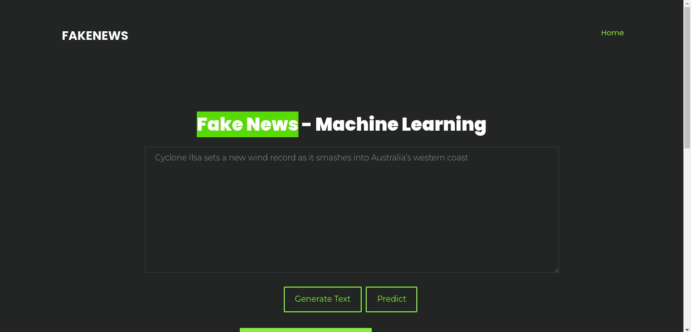
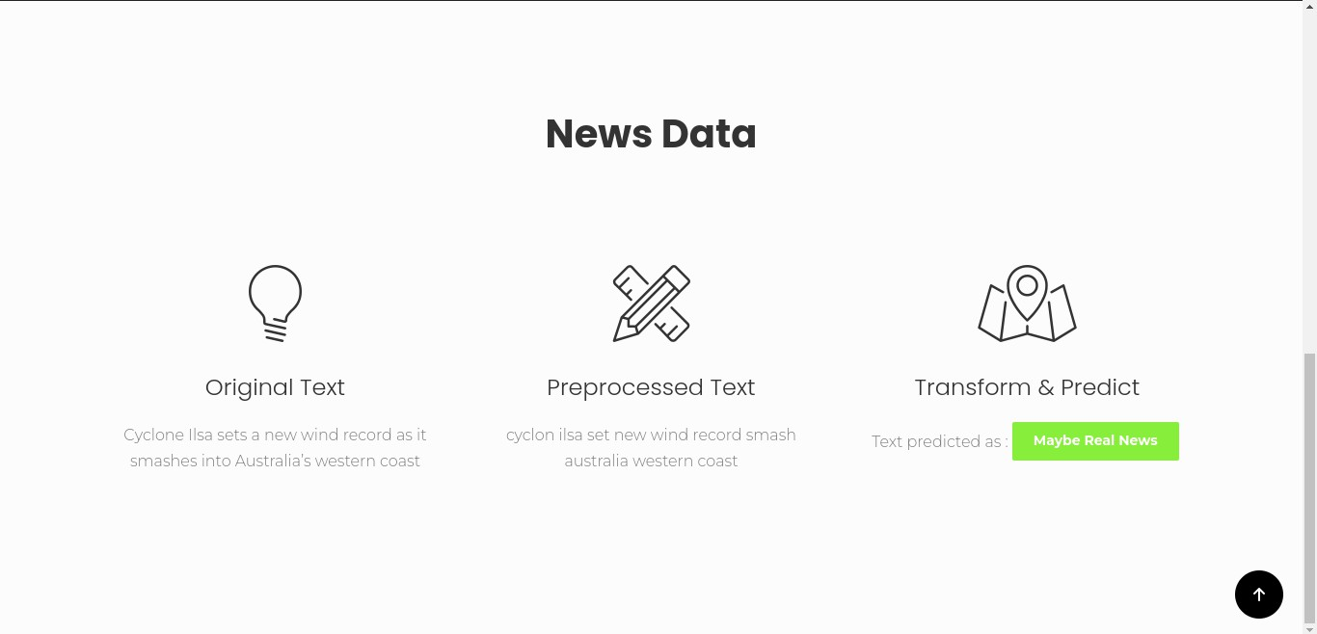

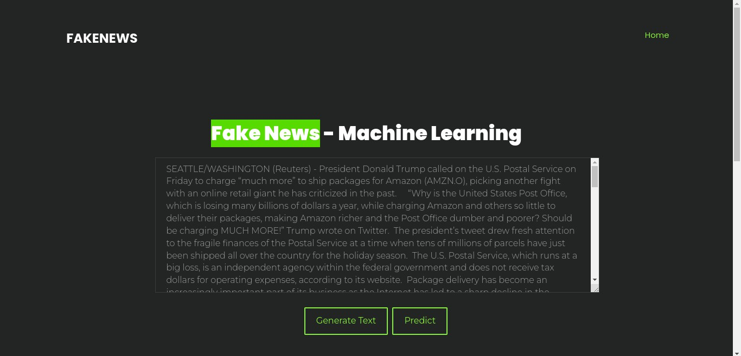
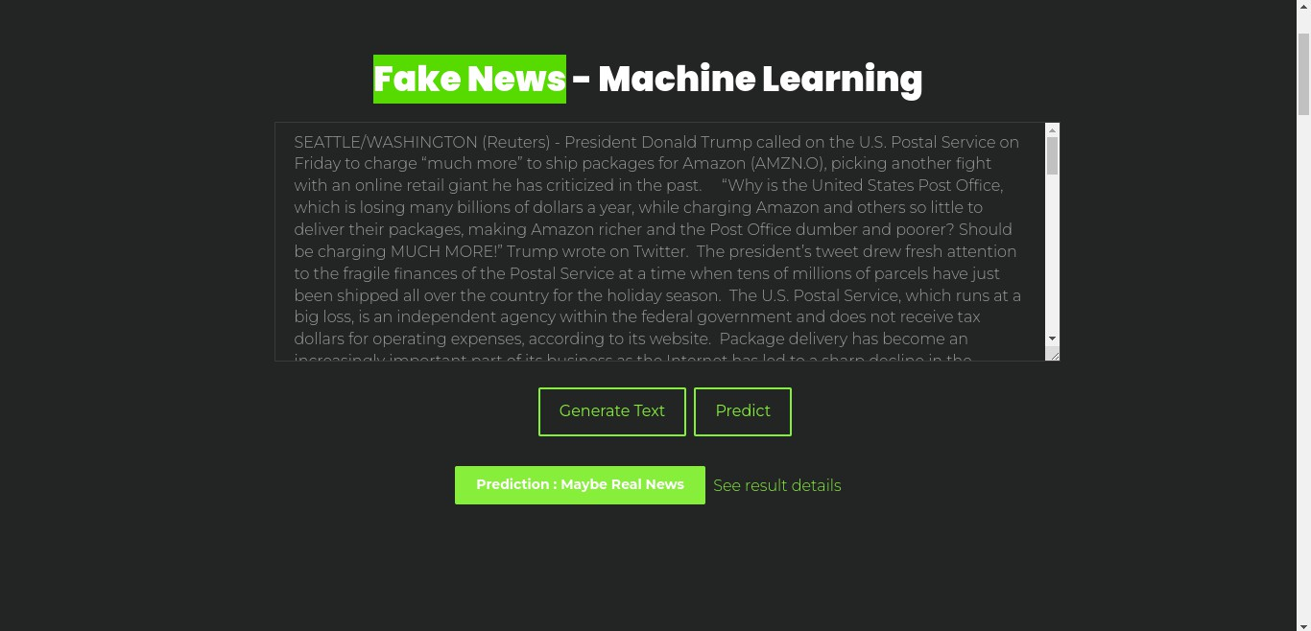

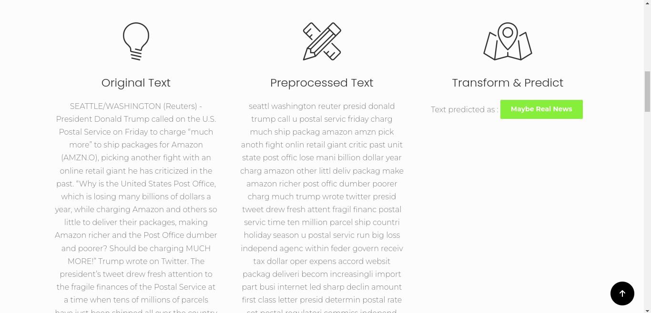

REFERENCES

- Yang, S., Shu, K., Wang, S., Gu, R., Wu, F. and Liu, H., 2019, July. Unsupervised Rumor detection on social media: A generative approach. In Proceedings of the AAAI conference on artificial intelligence (Vol. 33, No. 01, pp. 5644-5651).
- Kai Shu , Amy Sliva , Suhang Wang , Jiliang Tang , and Huan Liu,2017 september.
Rumor Detection on Social Media: A Data Mining Perspective

- Yanagi, Y., Orihara, R., Sei, Y., Tahara, Y. and Ohsuga, A., 2020, July. Rumor Detection with Generated Comments for News Articles. In 2020 IEEE 24th International Conference on Intelligent Engineering Systems (INES) (pp. 85-90). IEEE.
- Zhang, J., Dong, B. and Philip, S.Y., 2020, April. Fakedetector: Effective Rumor detection with deep diffusive neural network. In 2020 IEEE 36th International Conference on Data Engineering (ICDE) (pp. 1826-1829). IEEE.
- Thota, A., Tilak, P., Ahluwalia, S. and Lohia, N., 2018. Rumor detection: A deep learning approach. SMU Data Science Review, 1(3), p.10.
- Shu, K., Mahudeswaran, D., Wang, S., Lee, D. and Liu, H., 2020. RumorNet: A Data Repository with News Content, Social Context, and Spatiotemporal Information for Studying Rumor on Social Media. Big Data, 8(3), pp.171-188.
- Groza, A., 2020. Detecting Rumor for the new coronavirus by reasoning on the Covid-19 ontology. arXiv preprint arXiv:2004.12330. 50
- Gurav, S., Sase, S., Shinde, S., Wabale, P. and Hirve, S., 2019. Survey on Automated System for Rumor Detection using NLP & Machine Learning Approach. International Research Journal of Engineering and Technology (IRJET), 6(01), pp.308-309.
- Yang, K.C., Niven, T. and Kao, H.Y., 2019. Rumor detection as natural language inference. arXiv preprint arXiv:1907.07347.
- Cui, L. and Lee, D., 2020. Coaid: Covid-19 healthcare misinformation dataset. arXiv preprint arXiv:2006.00885.

- Qi, P., Cao, J., Yang, T., Guo, J. and Li, J., 2019, November. Exploiting multi- domain visual information for Rumor detection. In 2019 IEEE International Conference on Data Mining (ICDM) (pp. 518-527). IEEE.
- Srivastava, A., Kannan, R., Chelmis, C. and Prasanna, V.K., 2019, December. RecANt: Network-based Recruitment for Active Rumor Correction. In 2019 IEEE International Conference on Big Data (Big Data) (pp. 940-949). IEEE
- Long, Y., 2017. Rumor detection through multi-perspective speaker profiles. Association for Computational Linguistics.
- Wang, W. Y. 2017. ‖ liar, liar pants on fire‖: A new benchmark dataset for Rumor detection. arXiv preprint arXiv:1705.00648
- Jin, Z.; Cao, J.; Zhang, Y.; and Luo, J. 2016. News verification by exploiting conflicting social viewpoints in microblogs. In AAAI, 2972–2978.
- N. Grinberg, K. Joseph, L. Friedland, B. Swire-Thompson, and D. Lazer. Rumor on twitter during the 2016 us presidential election. Science, 363(6425):374–378, 2019.
- Magdy, A., and Wanas, N. 2010. Web-based statistical fact checking of textual documents. In Proceedings of the 2nd international workshop on Search and mining user- generated contents, 103–110. ACM.
- Ajao, O., Bhowmik, D. and Zargari, S., 2018, July. Rumor identification on twitter with hybrid cnn and rnn models. In Proceedings of the 9th international conference on social 51 media and society (pp. 226-230).
- De Sarkar, S., Yang, F. and Mukherjee, A., 2018, August. Attending sentences to detect satirical Rumor. In Proceedings of the 27th International Conference on Computational Linguistics (pp. 3371-3380).
- Shu, K., Sliva, A., Wang, S., Tang, J. and Liu, H., 2017. Rumor detection on social media: A data mining perspective. ACM SIGKDD explorations newsletter, 19(1), pp.22- 36.

